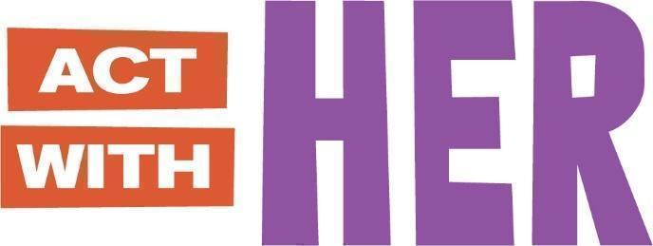

**PARTICIPANT BOOKLET**

**For Older Adolescent Boys’ Clubs**

**(Ages 15 - 19)**

Global version designed for adaptation

May 2023

THIS BOOKLET BELONGS TO:

MY MENTOR’S NAME IS:

IF YOU FOUND THIS BOOKLET, PLEASE RETURN TO ME.

THANK YOU!

**SESSION 1: WELCOME AND GOALS**

*JOURNAL ENTRY*

Today, we learned about ASPIRATIONS and GOALS.

* Aspirations are my dreams for the future.
* Goals have a deadline and will help me to reach my aspiration.

My aspiration is to:

**Goal #1:**

**Goal #2:**

**Goal #3:**

I (GUARDIAN / PARENT NAME) will support my child to reach their goals!

**SESSION 2: GENDER AND SOCIAL EXPECTATIONS**

*FACTSHEET*

Today, we learned about GENDER and GENDER ROLES.

* Gender roles are different from biological roles.
* Gender means how society defines being a woman or man.
* Gender norms and roles mean expectations of how men and women are expected to act and behave.

**Activity 1: Is it Sex or Gender?**

Put a **X** if the picture is GENDER or SEX.

|  |  |  |
| --- | --- | --- |
|  | Gender | Sex |
| 1.  Pregnant woman |  |  |
| 2.  Person cleaning |  |  |
| 3.  Caring for baby |  |  |

**Activity 2: Draw!**

Gender expectations change over time! Draw an image of the people in the table below.

|  |  |  |
| --- | --- | --- |
| My Grandfather | My Father | Me |
|  |  |  |

I also learned…

**SESSION 3: OUR CHANGING BODIES**

*FACTSHEET*

Today, we learned about CHANGES IN THE BODY DURING PUBERTY.

**GIRLS**

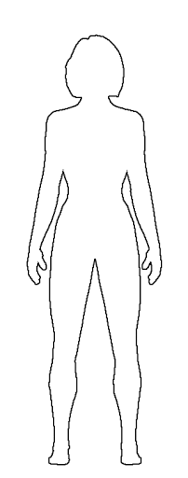

**Emotions:** Want to be more independent, spend less time with family and more time with friends. Can feel happy one minute and sad or angry the next.

**Skin:** Becomes oily, sometimes with pimples or acne

**Breasts**: Grow, swell and hurt just a little bit

**Sweat:** Perspiration increases, and body odor may appear

**Body size:** Hips widen, weight and height increases. Girls can reach full height before boys, but before puberty is finished boys will generally be taller than girls.

**Female sexual organs:** Period (menstruation) begins. Vaginal wetness increases, may have sexual feelings.

**Hair**: Hair increases on leg, under arms, and in pubic areas

**Motor functions:** May feel clumsy because your body is getting bigger and long and your brain needs to get used to it.

**SESSION 3: OUR CHANGING BODIES (Continued)**

*FACTSHEET*

**BOYS**

*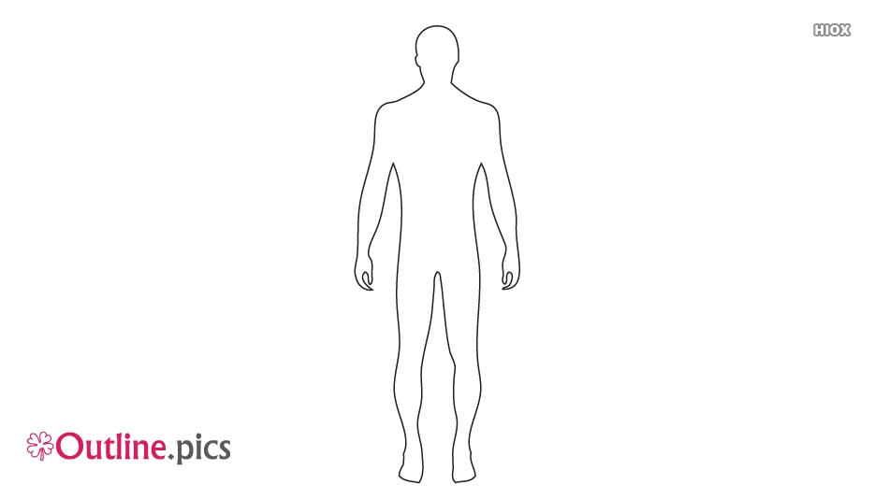*

**Emotions:** Want to be more independent, spend less time with family and more time with friends. Can feel happy one minute and sad or angry the next.

**Skin:** Becomes oily, sometimes with pimples or acne

**Voice**: Will deepen and crack. It can go from high to low, this is normal.

**Sweat:** Perspiration increases, and body odor may appear

**Body size:** Shoulders and chest broaden. Weight and height increases. Boys will generally be taller than girls by end of puberty.

**Male sexual organs:** Wet dreams and erections occur, and penis and testicles grow larger. May have sexual feelings.

**Hair**: Hair increases on leg, under arms, and in pubic areas

**Motor functions:** May feel clumsy because your body is getting bigger and long and your brain needs to get used to it.

**SESSION 4: PREVENTING UNWANTED PREGNANCY**

*FACT SHEET*

Today, we learned about MENSTRUATION AND HOW TO PREVENT UNWANTED PREGNANCY.

* Menstruation (your period) is a normal and natural process!
* Menstruation is when the uterus gets rid of the blood and tissue.
* Menstruation is not a sickness, illness, disease, infection, harmful, dirty, shameful, unclean or otherwise ‘negative’.[[1]](#footnote-1)

**During Menstruation / Period**

**Before Menstruation/ Period**

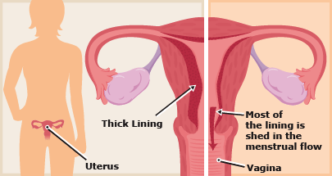

**SESSION 4: PREVENTING UNWANTED PREGNANCY (Continued)**

*FACT SHEET*

* The #1 way to prevent pregnancy is to not have sex.
* Other ways to prevent pregnancy are CONTRACEPTIVE METHODS like the ones below!

|  |  |
| --- | --- |
| **Male and Female Condoms** | **Contraceptive Pills** |
| **Injectables**  **Injection Needle_black** | **IUDs**  **IUD_black** |
| I also learned… | |

**SESSION 5: OUR POWER AS MEN**

*JOURNAL ENTRY*

Today, we learned about different kinds of POWER and how we as men can share our POWER to improve the lives of others.

|  |  |
| --- | --- |
| **Positive Forms of Power** | **What does it mean?** |
| https://lh5.googleusercontent.com/srEGHMUH4VyRKevJwjRlCedokEnKjXODt5jjEmf4sVXifOjpPpDHi7WgfvrtatfG0lNenJMgO4ACtjemrp4X3Q3VbaYW-YNzLqt7eIZrjS1H9u9Na9w0i7LTGefJanftRezaB_qA **Power to** | You know it is possible to act, and decide to take action. You develop your skills and realize you have the power to make change! |
| https://lh3.googleusercontent.com/at_MRzA6ATn2ehXb1jlusCqqoAc6RBStsqInqDNowuL6m-L8JWN7EmjWfLKaoUJpYA9_jiao75tM6gP6M9EhMR-yuDeKr6K8L53yiryE6aLtfaiTfS2HLHqRArIPh3ALkN5VeY8t**Power with** | Join with others to plan and take action together. With this kind of power, you feel capable and united! |
| **Power within** | You have confidence in yourself and good self-esteem. |

I also learned…

**SESSION 6: EVERYDAY VIOLENCE AGAINST WOMEN**

*JOURNAL ENTRY*

Today, we learned about different kinds of VIOLENCE and how we can prevent it.

* We learned that Sexual harassment and rape is never a girl’s fault![[2]](#footnote-2)



Denial of resources, opportunities or services

Sexual, psychological and physical exploitation and abuse

Forced trafficking and prostitution

Domestic violence

Early marriage

Rape

I also learned…

|  |  |
| --- | --- |
|  |  |

**Places I Can Go for GBV Support**

Name of Police Station / One Stop Center:

Name of Officer:

Address:

Phone Number:

Name of Clinic or Health Center:

Name of Provider:

Address:

Phone Number:

**SESSION 7: JOINT SESSION – STEPPING UP TOGETHER**

*JOURNAL ENTRY*

Today, we learned ways in which we can prevent and interrupt sexual harassment and other types of gender-based violence in the community.

Here are some ways to “stand up” when I witness violence or harassment:

|  |  |
| --- | --- |
| **Intervention:** | **Examples:** |
| **https://lh3.googleusercontent.com/at_MRzA6ATn2ehXb1jlusCqqoAc6RBStsqInqDNowuL6m-L8JWN7EmjWfLKaoUJpYA9_jiao75tM6gP6M9EhMR-yuDeKr6K8L53yiryE6aLtfaiTfS2HLHqRArIPh3ALkN5VeY8tTeam Up** | * If you do not know the person well, if you think they may respond with violence, or if you think they will not be convinced by just one person, get other young men and women (or others from the community) to speak with them. * Get a friend or two and return to the situation. * If near homes, school, or shops –get a trusted adult and ask them to step in. * If this situation is among your friend group, speak with them privately. |
| https://lh5.googleusercontent.com/srEGHMUH4VyRKevJwjRlCedokEnKjXODt5jjEmf4sVXifOjpPpDHi7WgfvrtatfG0lNenJMgO4ACtjemrp4X3Q3VbaYW-YNzLqt7eIZrjS1H9u9Na9w0i7LTGefJanftRezaB_qA**Distract** | * Compliment what the person has done well before bringing up what they have done wrong.   + Interrupt to ask for the time or directions, possibly giving the person being targeted a chance to leave. |
| **Direct Approach**  https://lh3.googleusercontent.com/07wGTOtTaFZBdya29dNLeqQ7e8el1djcTjhc_XtsCi07F2uTlMu_n2IQ4TG9xg6orpyr_SuzkT-BU8I50asbU1wcQ-Yb5S040qoRuAaeILHsw3LQ0-CP1R1dusED4P3vZJ0Pi6rR | * Calmly ask the person to explain their actions and why they are using violence.   + Ask questions about what they are doing. This may help the person realize what they are doing is a problem.   + Tell the person about the harm they can cause to others and themselves.   + Suggest other things they can do.   + Talk about your concern for the person. For example, say you do not want them to get into trouble with the teachers or police.   + Speak from your own perspective. Use ‘I’ statements and explain how you feel about a person’s actions and how they bother you. |
| https://lh3.googleusercontent.com/m6BNWnGj0UsBfZA0X7JkUPEFrYsjODZqOSHTSt8-Dr5TkNXe7QEbPXD8ub1d8Jn4SoCNsjkGDEOyG3Q0gRqcoozFiNCQdyb9b0ezf6cqr2NHkkq8zLrHFXotQsa0uh97_YCz7AB8**Call an authority figure** | This is the most realistic approach if the threat of violence is severe. |

I also learned…

**SESSION 8: EXPRESSING MY EMOTIONS**

*JOURNAL ENTRY*

Today, we learned ways in which we can express our emotions without using violence.

Here are some ways to prevent violence, particularly against women and girls:

|  |  |
| --- | --- |
| **What To Do When I Am Angry** | |
| **Know what makes you angry.**  https://lh3.googleusercontent.com/IgkBd-4tEjFbe4eXBiLBa030L0UaA3PwWZQhLKx7Vrzf2O_4WgUzZnS6OaUKBnx3hqqIKZdUQRBZDQ8O9CaIy8WMJhfVIOSaUghsVQVLQMQJ6SaAidzCwhXTikg3UmuNemlyJ0IX | * Do you get very angry when you’re embarrassed, frustrated, insecure, disrespected? |
| **Notice the warning signs.**  https://lh3.googleusercontent.com/bL-KsiAkby8SERWZvv4Lr1eulfHld-cA49bY1GKRWGN2afAhb4HSpelDSwgxA_dJZXRgC2h1t3FJkN9_i09blCNSjYQ7mJoJYaeISakehTjrmpx9aJwBoJQVLa-f2-NIdF5B6CRP | * Warning signs can be stress, increased heart rate, negative thoughts, raised voice |
| https://lh3.googleusercontent.com/NP7uT0byHSVSPC-OPAszEpOw8ajNaiHv55ZdH2ePG6dptSL_mdbTqAXwgHbLHadOrOUjd8lZpLvnOikAsc_XcqS9x9vCHb1C_CX592TxAxqmWq-d-ZSTi8NW_bUN6BLnN-SlQZBB | * STOP. Take a deep breath. Consider your options. Proceed. Practice this regularly. |
| **Take a time out.**  https://lh5.googleusercontent.com/tWfXiqtwQlnxqutSgWo6fL1eVe9fFq8beiymIi8936HSPToPCbZ21Q2IdVBTc1_pY6jHFsv547g02-lxmlz6xayDocHPnCfiIj088RpMOuS5aiLd5dwrd8-ppQ3t6UFad0PM_OmQ | * The problem may not change, but how you deal with it can. Stop thinking bad thoughts and be happy with what you have. |

I also learned…

**SESSION 9: STAY IN SCHOOL / CONTINUE LIFELONG LEARNING**

*JOURNAL ENTRY*

Today, we learned about the importance of staying in school and for continued learning out of school in order to reach our goals.

Fill in the circle with names or drawings of people who you can go to if you need help to stay in school or continue learning if you are out of school.

Draw a picture of what you will do to stay in school.

|  |
| --- |
|  |

Draw a picture of what you will do to continue learning if you are out of school.

|  |
| --- |
|  |

I also learned…

**SESSION 10: GOOD COMMUNICATION SKILLS**

*JOURNAL ENTRY*

Today, we learned about good verbal and nonverbal communication skills.

Draw what **good body language** looks like!

|  |
| --- |
|  |

This is GOOD COMMUNICATION because…

Draw what **bad body language** looks like!

|  |
| --- |
|  |

This is bad communication because…

I also learned…

**SESSION 11: NEGOTIATING WITH FAMILY MEMBERS (JOINT SESSION)**

*JOURNAL ENTRY*

Today, we learned the 4 NEGOTIATION SKILLS to use with our families and in our relationships.

|  |  |
| --- | --- |
| STEP 1 | https://lh4.googleusercontent.com/jH9Hfl2OISV13mOXuJm_YCWCweqW2lpVHls5NiPf6RPm6c8Ehko6_TthQaZF5brKR7SI5V-kC5BnnZJTyW-ruya9WQ44NOth1PzDWA9pJLkFp1L6Crn3C2kk9G9nHl3nTXVr275_Establish ground rules for yourself. |
| STEP 2 | State what you want and why.  https://lh4.googleusercontent.com/ZTmQgzUnItA3DtBhyHr_iDNZeMPCuSeYinPynUg5Hx7UI58XRL-iprKoacQd9ZQv1Uk7caBjYhHR_vxNy2TwqMPmEBhfCBNftPaxRMRZjglXakwdFVAAfzsiPMa4fEtYlnwtPiEI |
| STEP 3 | Brainstorm solutions. |
| STEP 4 | Come to an agreement. |

How will you use your negotiation skills?

I also learned…

**SESSION 12: CULTURAL IDEAS ABOUT MANAGING GIRLS SEXUALITY: FEMALE GENITAL CUTTING AND CHILD, EARLY AND FORCED MARRIAGE**

*JOURNAL ENTRY*

Today, we learned that FEMALE GENITAL CUTTING (FGC) is bad for girls’ health! [[3]](#footnote-3)

**Mental health disorders**

such as depression or anxiety

**Sexual dysfunction**

such as painful intercourse

**Complications with**

**the giving birth**

such as difficult labor

**Complications with**

**the body**

such as menstrual

problems or pelvic pain

I also learned…

We also learned about CHILD MARRIAGE.



If I need help, I will ask

**SESSION 13: ALTERNATIVE MODEL MEN IN THE COMMUNITY**

*JOURNAL ENTRY*

Today, we met a Model Man from the community.

His name was…

I liked his story because…

I learned…

This is me as a Model Man!

|  |
| --- |
|  |

**SESSION 14: MY MONEY, MY LIFE, MY PLAN**

*JOURNAL ENTRY*

Today, we learned about SAVING MONEY.

**$$**

My savings goal is: \_\_\_\_\_\_\_\_\_\_\_\_\_\_\_\_\_

My picture of what I will buy when I save enough money.

|  |
| --- |
|  |

To save money, I will…

1.

2.

3.

I will save my money in a SAFE PLACE.

**SESSION 14: MY MONEY, MY LIFE, MY PLAN (continued)**

*JOURNAL ENTRY*

We also learned about Village Savings and Loan Associations (VSLA).

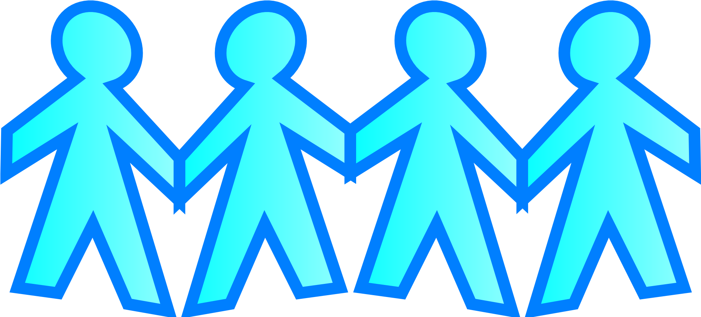

* VSLA is a group of people that meets in a safe place to save their money and get loans.

I also learned

**SESSION 15: HOW AM I DOING? MY GOALS REVISITED**

*JOURNAL ENTRY*

Have I reached my 2 goals? *Put an* ***X*** *next to your answer.*

|  |  |
| --- | --- |
| * YES | * NO |

If **NO**, this is my plan to reach my goals:

This week I can…

Next week I can…

Next month I can…

If **YES**, my new goal is:

**NEW GOAL:**

**SESSION 16: HAVING FUN IN RELATIONSHIPS – SEXUAL CONSENT**

*JOURNAL ENTRY*

Today, we learned about SEXUAL CONSENT, SEXUAL COERCION, and HOW TO CHECK-IN with my partner.

1. SEXUAL CONSENT is like TEA!

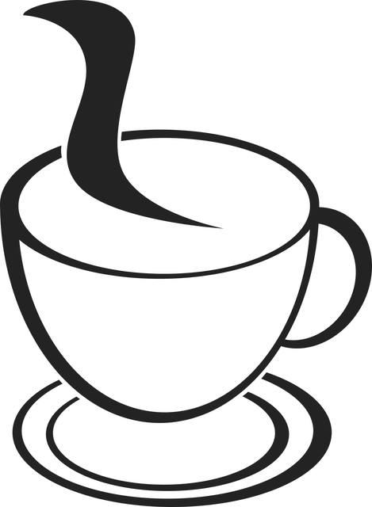

It means you discuss and agree together to do a sexual act you both want.

1. SEXUAL COERCION is when you force someone to do something sexual they do not want to do.
2. Important ways to CHECK IN with my partner are…

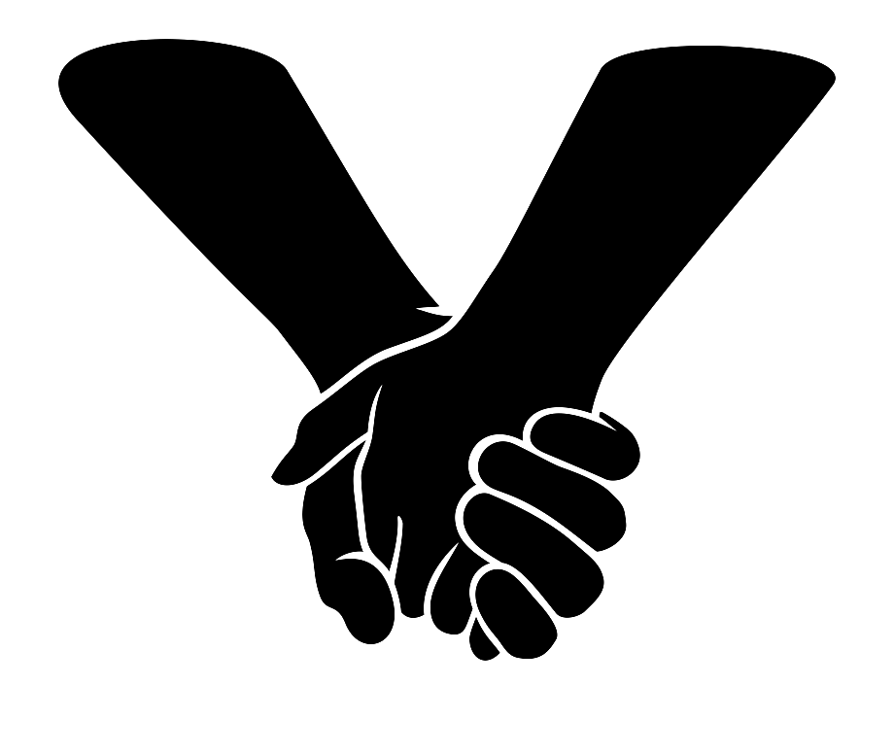

“Are you OK with this?”

“Are you comfortable with this?

“How is this making you feel?”

I can also say…

**SESSION 17: UNDERSTANDING GENDER AND POWER TOGETHER (JOINT SESSION)**

*JOURNAL ENTRY*

Today, we learned more about POWER.

* Power can be (+) or (-) depending on a person’s own experience.
* It is important for me to use my power to help others.

I also learned…

This is how the world will look if everyone shared their power!

|  |
| --- |
|  |

**SESSION 18: SEXUALLY TRANSMITTED INFECTIONS**

*FACTSHEET*

Today, we learned about SEXUALLY TRANSMITTED INFECTIONS (STIs), including HIV.

***What are STIs?***

STIs are infections usually spread from person to person through sexual activity. Some STIs can also be spread through sharing needles.

Two common STIs are Gonorrhea and Chlamydia. These are bacterial infections.

Three other common STIs are the Human Papilloma Virus (HPV) genital herpes, and the Human Immunodeficiency Virus (HIV). These are viral infections.

***How do I know if I have an STI?***

You may feel:

* Pain or burning during urination
* Painful bumps on the penis
* **Nothing at all!**

***What is HIV?***

HIV stands for Human Immunodeficiency Virus. It **cannot** be cured with medicine.

**SESSION 18: SEXUALLY TRANSMITTED INFECTIONS (continued)**

*FACT SHEET*

HIV is spread through:

* Having sex with someone who is infected with HIV
* Exposed to blood with HIV (e.g. blood transfusions, sharing needles)
* During pregnancy and childbirth if the mother has HIV

***How can I protect myself from STIs?***

* Do not have sex
  + Do not share sharp instruments
  + Get vaccinated for HPV
  + Using condoms correctly and every time when you decide to have sex.
  + When you decide to have sex, get tested regularly.

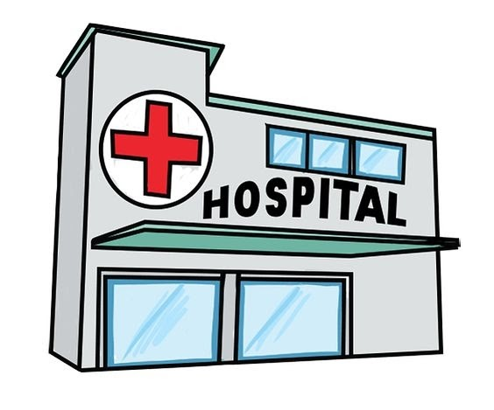***HEALTH CLINIC NEAR ME***

Name of Clinic or Health Center:

Name of Provider:

Address:

Phone Number:

**SESSION 19: EATING HEALTHY FOR ME!**

*FACT SHEET + JOURNAL ENTRY*

Today, we learned about MOVE, GROW, and SHINE foods to keep our bodies healthy.

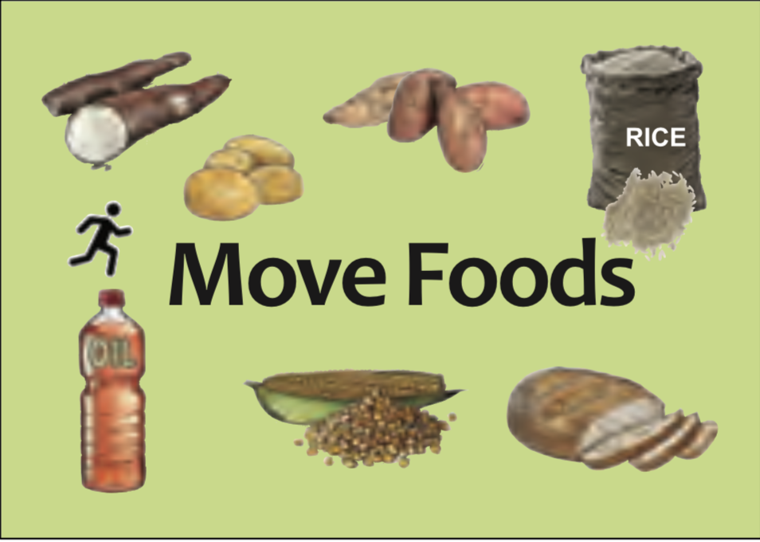

**Move Foods**

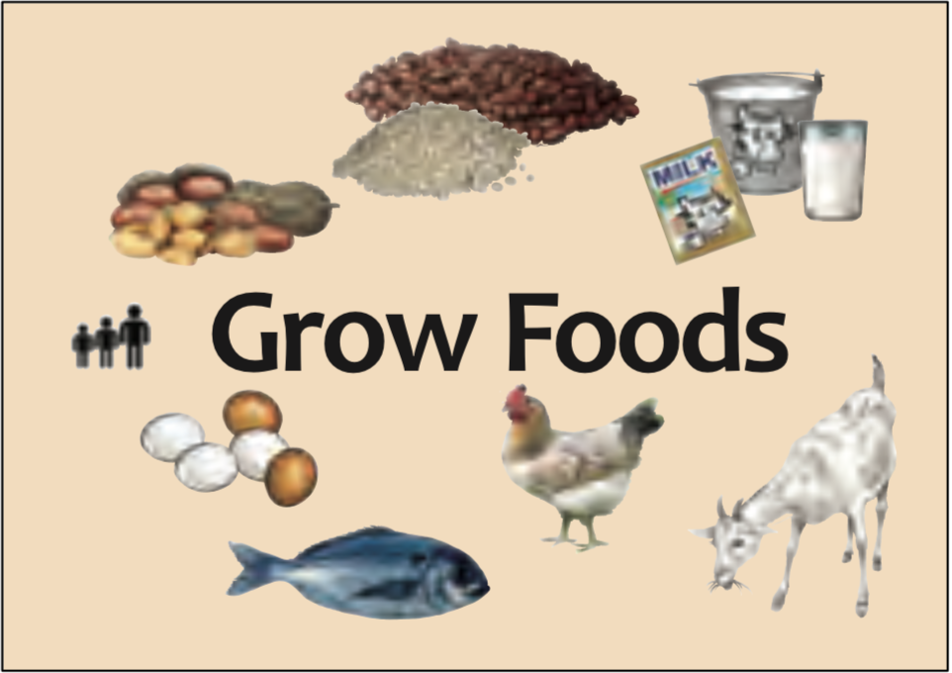

**Grow Foods**

**SESSION 19: EATING HEALTHY FOR ME! (continued)**

*FACT SHEET + JOURNAL ENTRY*

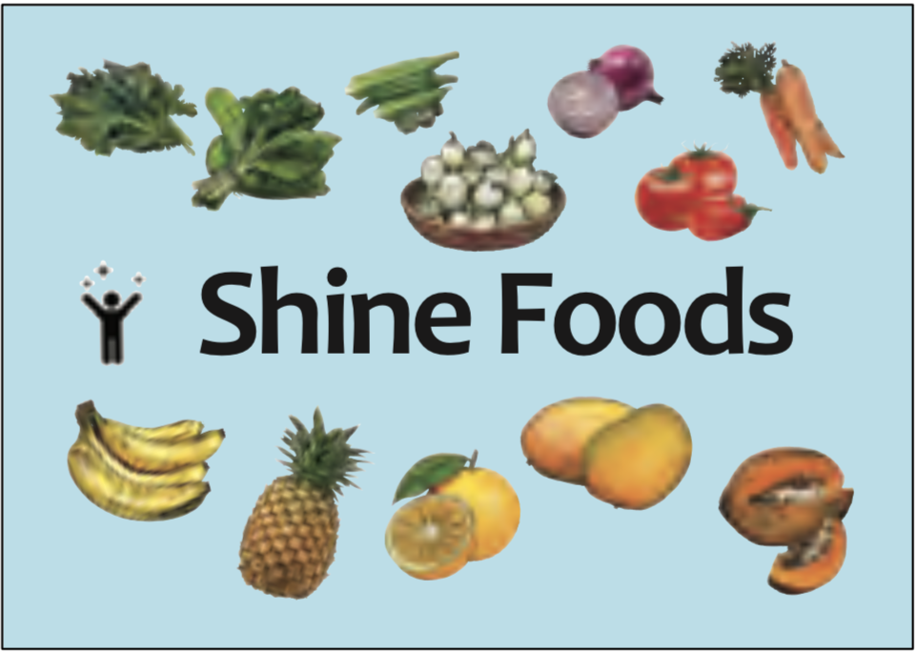

**Shine Foods**

I also learned…

**SESSION 19: EATING HEALTHY FOR ME! (continued)**

*FACT SHEET + JOURNAL ENTRY*



Draw what Move, Grow, and Shine foods you want on your plate!

**SESSION 20: I LOVE WHO I AM**

*FACTSHEET*

Today, we learned about GENDER IDENTITY, and GENDER EXPRESSION, SEXUAL ORIENTATION.

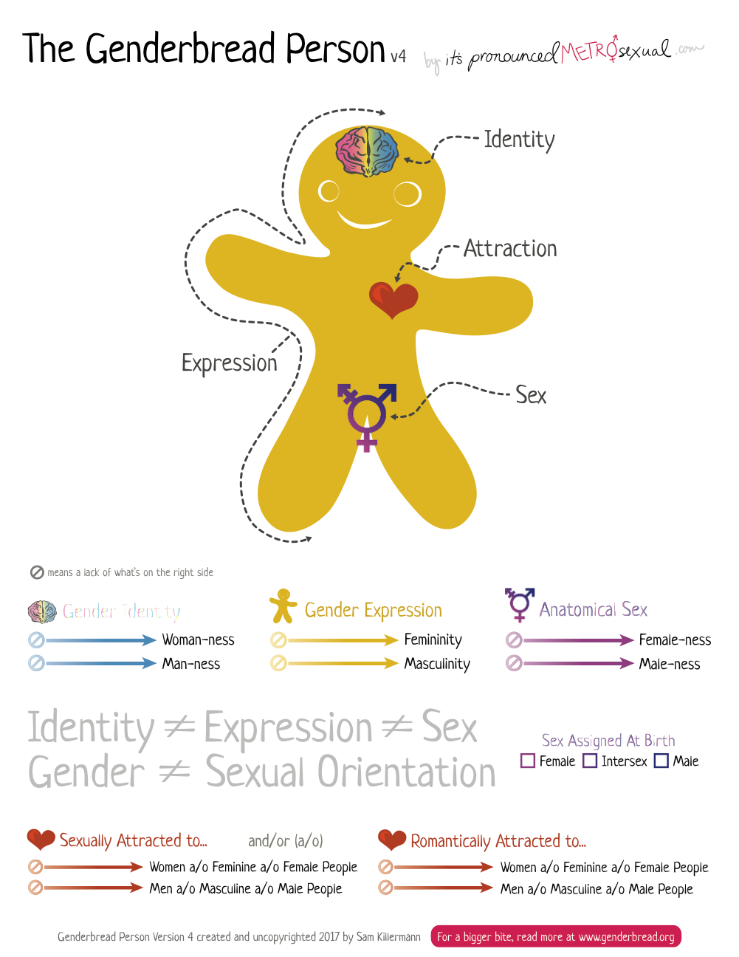

**SESSION 21: STAYING SAFE IN THE COMMUNITY**

*WORKSHEET*

Today, we learned how to do a RISK ASSESSMENT and SAFETY PLAN. We also learned about SAFETY SKILLS.

1. RISK ASSESSMENT

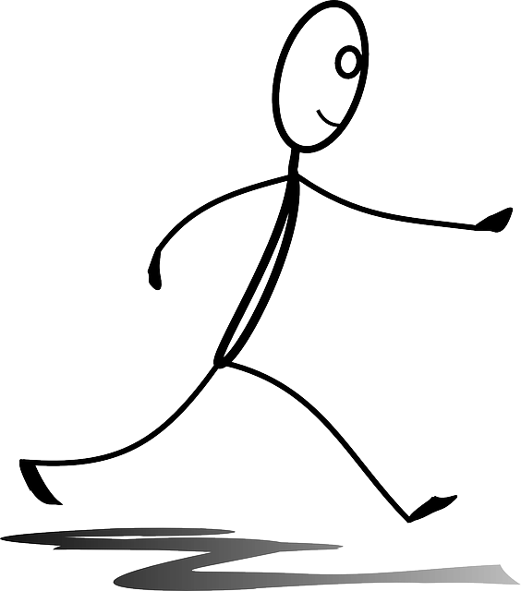Match the sentence with the picture!

|  |
| --- |
| *Example:*  Banana |
| **Step 1:** Learn about the risky areas in your area. |
| **Step 2:** Make a plan to stay safe. |
| **Step 3:** Watch and observe what is around you at all times. |
| **Step 4:** Go with a trusted person if you go to risky areas. |







**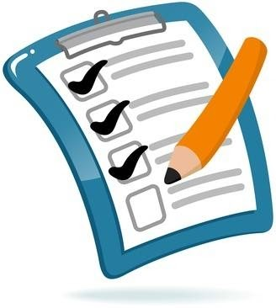SESSION 21: STAYING SAFE IN THE COMMUNITY (continued)**

1. SAFETY PLAN

**MY SAFETY PLAN**

I feel unsafe when I go to \_\_\_\_\_\_\_\_\_\_\_\_\_\_\_\_\_\_\_\_\_\_\_\_\_\_.

I plan to stay safe by \_\_\_\_\_\_\_\_\_\_\_\_\_\_\_\_\_\_\_\_\_\_\_\_\_\_\_ and

\_\_\_\_\_\_\_\_\_\_\_\_\_\_\_\_\_\_\_\_\_.

If I need help, I will ask \_\_\_\_\_\_\_\_\_\_\_\_\_\_\_\_\_\_\_\_\_\_\_ and

\_\_\_\_\_\_\_\_\_\_\_\_\_\_\_\_\_\_\_\_\_.

I will share my Safety Plan with \_\_\_\_\_\_\_\_\_\_\_\_\_\_\_\_\_\_\_\_\_\_.

**SESSION 21: STAYING SAFE IN THE COMMUNITY (continued)**

1. SAFETY SKILLS

|  |  |
| --- | --- |
| **Safety Skill:** | **Examples:** |
| Say clearly what you want. | * Simple: “No, thanks”, or “No” * Strong: “No!” “Don’t do that!” * Again and again: “No, no, **NO!!!**” |
| https://lh4.googleusercontent.com/TQw8kRQqrzld8-mYiQ0iOd0DXtDOHjg79CmmpVet52vw5SuMMiCdd8uKCe6WFY_FvQDY0hizVhfQ65v02q5m59KPvkbZrzlyrN8rEl0J5N92Fx4fLrf4PmoCPxArS1ORwgPP6qDO  Be loud! | * Talk in a loud voice. * Scream for help if you feel you are at risk. |
| https://lh6.googleusercontent.com/a7_pZsDoJWWpfZHt1OreCyTfrEDteZ4stpEALAsAYr-QJRMq-bzpTH9NHu8y9GzbBHI9n-SL91RI7o-wxLh13gqcsvLhayMXRy2SD0EdFcIw91geA5Epg8mUraeW4oaf683_NYQI  Create distance. | * Push the person away without smiling and walk away. * Leave and go somewhere safe. |
| Stay away. | * If you think you will be pressured, don’t go with the person. * Avoid being alone with a date or new boyfriend until you trust them. |
| https://lh6.googleusercontent.com/JJcWharftLCIz8Dz6jAM9wlmxCYa7EEkwMTpYKkUxIfWkMrRfoLfLst2lTgn5INllbagPQjgJ6SJv2gcqmg3w-9O55JiZd_GXbRYY0ZqHgloS7m0SKNHL3H2MSPRo-dLWaOAnT3_  Safety in numbers. | * Walk with a group of friends or family members. Keep trusted friends nearby. * Always tell someone where you are going. |
| https://lh5.googleusercontent.com/XqzQbaW9l3k4UwbWH-WiGYC20AAWp6-5mcRGcvwOL43BG36e8vZ0C20vVCZPcudTNWaQWNtxr7ER_-yNonBYXgpuqwsGRJZr-eVOjrkkfiQVfDgf0Gz7wjpPQ552sGRXOZHujAl5  Call in support. | Say you will tell somebody with power such as parents, counselors, relatives, and police. |

**SESSION 22: COMMUNITY MAPPING AND SAFETY**

**(JOINT SESSION)**

Today, we learned about how to keep the community safe for everyone.

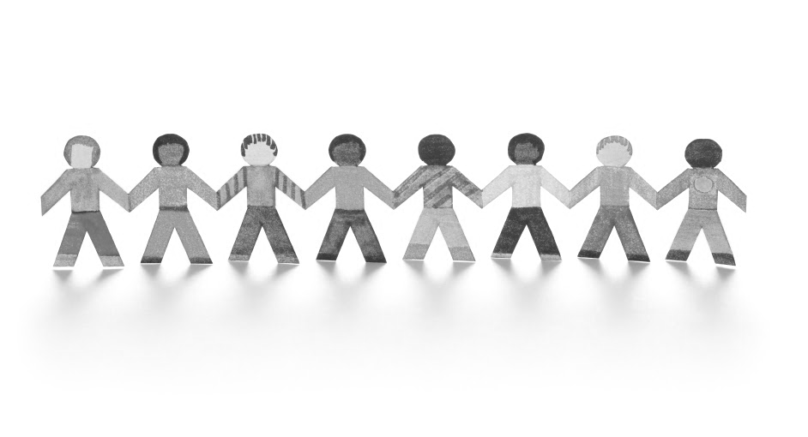

This is a picture of my community when it is safe for both boys and girls!

|  |
| --- |
|  |

**SESSION 23: SUBSTANCE USE AND ABUSE**

*FACTSHEET*

Today, we learned about DRUG and ALCOHOL ABUSE.

If someone pressures me to do drugs and drink alcohol, I will…

**I CAN ALSO…**

|  |  |
| --- | --- |
| Say “no” in a clear and firm voice. |  |
| Ask to do something else. | https://lh3.googleusercontent.com/90iiDaKfyMEy-Pk-9BfuCNOOjca-G9I3cM4imb2ifR58RLOISEZ3IZ0Jh_QKe88ec7fyoxuJHTh-MksJYS-PyO8fdbirDJx8hzD9sFVaGepSnC8TqK8D8vXYZgY-kWqYEdejma3f |
| Walk away. | https://lh6.googleusercontent.com/a7_pZsDoJWWpfZHt1OreCyTfrEDteZ4stpEALAsAYr-QJRMq-bzpTH9NHu8y9GzbBHI9n-SL91RI7o-wxLh13gqcsvLhayMXRy2SD0EdFcIw91geA5Epg8mUraeW4oaf683_NYQI |
| Be with other friends. |  |

**SESSION 23: SUBSTANCE USE AND ABUSE (continued)**

If someone I care about is abusing drugs or alcohol, I can….

*I also learned…*

**SESSION 24: KEEPING MYSELF STRONG**

* *TAKE AND ADAPT SESSION FROM I LOVE EXERCISE IN YOUNGER GIRLS BOOKLET*

Today, we learned about EXERCISE.

It is good to exercise because…

* I am growing strong muscles.
* I need to have fun and release energy!
* Having fun brings blood to my brain and helps me learn.

This is how I will exercise and stay strong!

|  |
| --- |
|  |

**SESSION 25: WRAP UP AND NEXT STEPS**

***CONGRATULATIONS!***

You have learned so much!



Draw in the bubbles below what you have learned about each topic.

**Finance**

**Gender**

**Health**

**Violence**

**Education/**

**Learning**

**Communication**

1. Image from <https://kidshealth.org/en/teens/menstruation.html> [↑](#footnote-ref-1)
2. Infographic from the International Federation of the Red Cross and Red Crescent Societies. <https://www.ifrc.org/Global/Photos/Asia%20Pacific/GBV%20page/GBV%20infographic_FINAL3.pdf> [↑](#footnote-ref-2)
3. Infographic from World Health Organization on FGM: <https://www.who.int/reproductivehealth/publications/fgm/fgm-infographic-3.pdf?ua=1>. [↑](#footnote-ref-3)