

**PARTICIPANT BOOKLET**

**For Parents/Caregivers of Older Adolescents**

**(Ages 15 - 19)**

Global version designed for adaptation

May 2023

THIS BOOKLET BELONGS TO:

LOCATION OF THE PARENTS GROUP MEETINGS:

MEETING TIME:

IF YOU FOUND THIS BOOKLET, PLEASE RETURN TO ME.

MY CONTACT INFORMATION:

**SESSION 1: ORIENTATION TO THE AWH PROJECT**

*FACTSHEET*

Welcome to the Parents Participant Guide!

This Booklet is yours to keep. Inside, there is information about how you can support your children to become happy, healthy adults.



* Teaches skills to empower **adolescent boys and girls** to become successful, healthy adults.
* Teaches **parents** how to support their adolescent children.

My Notes:

3 Factors

Adolescents need 3 things from YOU to grow up safe and healthy:

|  |  |
| --- | --- |
| 1. | Family connectedness |
| 2. | Close relationships with friends and peers |
| 3. | Education |

Tonight, share information about the Act With Her Program with someone in your home, such as your husband or wife.

I will share this with .

I will support my child on this project. Name of Parent/Guardian .

**SESSION 2: CHANGING ROLES**

*FACTSHEET + WORKSHEET*

Today, we discussed GENDER and BIOLOGICAL SEX.

**Sex vs Gender**

Put a **X** if the picture has to do with GENDER or SEX.

|  |  |  |
| --- | --- | --- |
|  | Gender | Sex |
| 1.  Pregnant woman |  |  |
| 2.  Person cleaning |  |  |
| 3.  Caring for baby |  |  |

**SESSION 2: CHANGING ROLES (continued)**

*FACTSHEET + WORKSHEET*

* Gender roles and norms for boys and girls are **different**.
* This difference creates **inequalities** between boys and girls.
* It is important to support your child to **challenge** gender inequalities.

What else did you discuss?

Goals for My Child



**What are your goals for your child?** DRAW.

|  |  |  |
| --- | --- | --- |
| GOAL #1 | GOAL #2 | GOAL #3 |

**SESSION 2: CHANGING ROLES (continued)**

*FACTSHEET + WORKSHEET*

**How can you help your child to reach their goals?**

|  |
| --- |
|  |

**SESSION 3: TALKING TO ADOLESCENTS ABOUT HEALTH AND SEX-RELATED TOPICS**

*JOURNAL ENTRY*

Adolescents are experiencing all kinds of physical and emotional changes right now! Your children need your love and support to get through this challenging time.

**GIRLS’ CHANGES DURING PUBERTY**

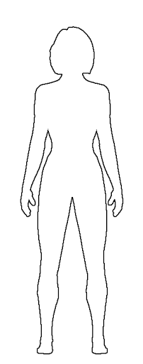

**Emotions:** Want to be more independent, spend less time with family and more time with friends. Can feel happy one minute and sad or angry the next.

**Skin:** Becomes oily, sometimes with pimples or acne

**Breasts**: Grow, swell and hurt just a little bit

**Sweat:** Perspiration increases, and body odor may appear

**Body size:** Hips widen, weight and height increases. Girls can reach full height before boys, but before puberty is finished boys will generally be taller than girls.

**Female sexual organs:** Period (menstruation) begins. Vaginal wetness increases, may have sexual feelings.

**Hair**: Hair increases on leg, under arms, and in pubic areas

**Motor functions:** May feel clumsy because your body is getting bigger and long and your brain needs to get used to it.

**SESSION 3: TALKING TO ADOLESCENTS ABOUT HEALTH AND SEX-RELATED TOPICS (continued)**

*FACTSHEET*

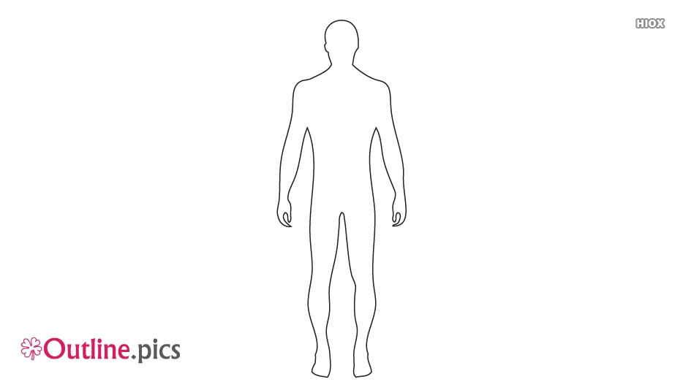**BOYS CHANGES DURING PUBERTY**

**Emotions:** Want to be more independent, spend less time with family and more time with friends. Can feel happy one minute and sad or angry the next.

**Skin:** Becomes oily, sometimes with pimples or acne

**Voice**: Will deepen and crack. It can go from high to low, this is normal.

**Sweat:** Perspiration increases, and body odor may appear

**Body size:** Shoulders and chest broaden. Weight and height increases. Boys will generally be taller than girls by end of puberty.

**Male sexual organs:** Wet dreams and erections occur, and penis and testicles grow larger. May have sexual feelings.

**Hair**: Hair increases on leg, under arms, and in pubic areas

**Motor functions:** May feel clumsy because your body is getting bigger and long and your brain needs to get used to it.

**SESSION 3: TALKING TO ADOLESCENTS ABOUT HEALTH AND SEX-RELATED TOPICS (continued)**

MENSTRUATION

* Is normal and natural!
* Is the shedding of tissue and blood from the vagina.
* Lasts between 4 to 7 days.
* Happens about once a month.

WHEN GIRLS FEEL PAIN FROM MENSTRUATION, THEY CAN:

|  |  |
| --- | --- |
| 1. Use a hot compress or take a pain reliever | https://lh5.googleusercontent.com/BGL5TWultSnc6z021qg8meo-PJ6ITwCyDWqgLqa1u0I3JevvRqoGVmIoH_3sasGiPbVka-lCiEajHNzrwF7XR_l1w4MvykdEsKYmAygzR4srXJ1RV2KjmZzU3JsbDvYFXtRff2JF    2. Relax! |
| https://lh6.googleusercontent.com/Ikwh_kp-ssYgWnPrUK_uToTcUDv794wid9FLuzxiABQo1UAvgzptMMzQZwQp7-9Fu23cWElDYHNn0w4tiV4Dv_J1C6XXu2_9GrVfdoE0g3XvpQLrK_s9lGIoxjvNQOmnQkXGVTl_  3. Drink tea | https://lh5.googleusercontent.com/vZhQnLFqJO248K9iErtRT_VYdbIkCY6Z-wgjuN5uO3IG3J665ASxq6L9HFqBA2kv6iUU3BVPwawIs0QD-UOVZeaW90qcDJ0jI5K76sVCSCUzZ0PcU0xH8NeusNlQkfkRuzARAxAd  4. Take a nap |
| https://lh6.googleusercontent.com/0pHirK8oXYNiIDfV58Sn1o5ScDtHQsoeBWw-r_0OM--WfOgcBtW4QiQU2O3fyFgnYC-wxUmM4ez0aucJ5YDh9YmMPbBTq0fKzhkBzuL7h6XXuoBgpOimEA9zw95_8mYipCHpj8Ut  5. If severe, go to the health clinic | |

**SESSION 3: TALKING TO YOUNG ADOLESCENTS ABOUT HEALTH AND SEX-RELATED TOPICS (continued)**

*FACTSHEET*

Early and unwanted pregnancy can be avoided. Adolescents who have strong parental support are more likely to delay childbearing.

How Does Pregnancy Happen?

* Adolescent girls and women release an egg from the ovaries inside of them about once a month. This is called ovulation.
* Menstruation means that an adolescent girl has started to ovulate.
* Adolescent boys begin to produce sperm.
* When a man and woman have sex, the egg and sperm can meet.
* When the egg and sperm meet, they fuse together and become an embryo. This is called conception.
* The embryo becomes a fetus and grows in the uterus. After 9 months a baby is born.

My Notes:

**SESSION 3: TALKING TO YOUNG ADOLESCENTS ABOUT HEALTH AND SEX-RELATED TOPICS (continued)**

*FACTSHEET*

Tips for Talking To My Child About Sex and Health

|  |  |
| --- | --- |
| Step 1. | Pick a good time to talk. |
| Step 2. | When you talk, make them feel calm. Say, *“This is normal and natural.”* |
| Step 3. | Give them little bits of information at a time. |
| Step 4. **???** | Ask if they have questions. |
| Step 5. | Keep the conversation short. |

**SESSION 4: SAFETY AND WELL-BEING**

*FACTSHEET*

GENDER-BASED VIOLENCE (GBV)- When a more powerful gender inflicts violence on a less powerful gender. In most cases, men inflict violence against women.[1]

Types of GBV



Denial of resources, opportunities or services

Domestic violence

Forced trafficking and prostitution

Early marriage

Rape

Sexual, psychological and physical exploitation and abuse

What Parents Can Do

* Observe if your child does not want to go to school. Ask them why.
* Your child needs your love and support. Be open to talk.
* Emphasize GBV and sexual harassment is never their fault!
* Talk with your child about solutions. Take action.

If my child experiences GBV, I can …

**SESSION 4: SAFETY AND WELL-BEING** (continued)

Places I Can Take My Child for GBV Support

Name of Police Station / One Stop Center:

Name of Officer:

Address:

Phone Number:

Name of Clinic or Health Center:

Name of Provider:

Address:

Phone Number:

**SESSION 4: SAFETY AND WELL-BEING (continued)**

*FACTSHEET*

Female Genital Cutting (FGC) is bad for girls’ health.[2]

**Complications with**

**the giving birth**

such as difficult labor

**Complications with**

**the body**

such as menstrual

problems or pelvic pain



**Sexual dysfunction**

such as painful intercourse

**Mental health disorders**

such as depression or anxiety

Other Notes

I will discuss this with

**SESSION 4: SAFETY AND WELL-BEING** (continued)

*FACTSHEET*



**SESSION 4: SAFETY AND WELL-BEING (continued)**

*FACTSHEET*

Benefits of delaying marriage:

* Girls bodies will be more mature and better able to deliver a healthy baby.
* Less risk to mothers and babies when the mother is over 18 years old.
* Fewer premature births (when babies come too early).
* Be in better relationships / marriages and less likely to experience violence.
* They will be more mature, and better able to care well for themselves and their children.

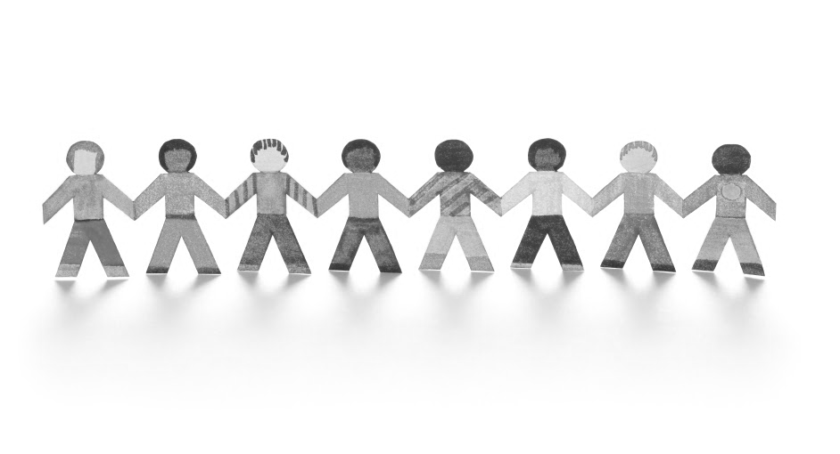

**Remember!**

**Your children need your love and support. Be open to communication and be prepared to listen.**

**SESSION 5: SUPPORTING MY CHILD’S FUTURE**

*Journal Entry*



Education and learning is important for your child.

Imagine your child once they finish school. Draw your vision here.

**MY CHILD:**



I will do this to help my child stay in school / continue to learn…

**SESSION 5: SUPPORTING MY CHILD’S FUTURE**

*Journal Entry*

Village Savings and Loan Associations (VSLA) can help my child to earn and manage money!

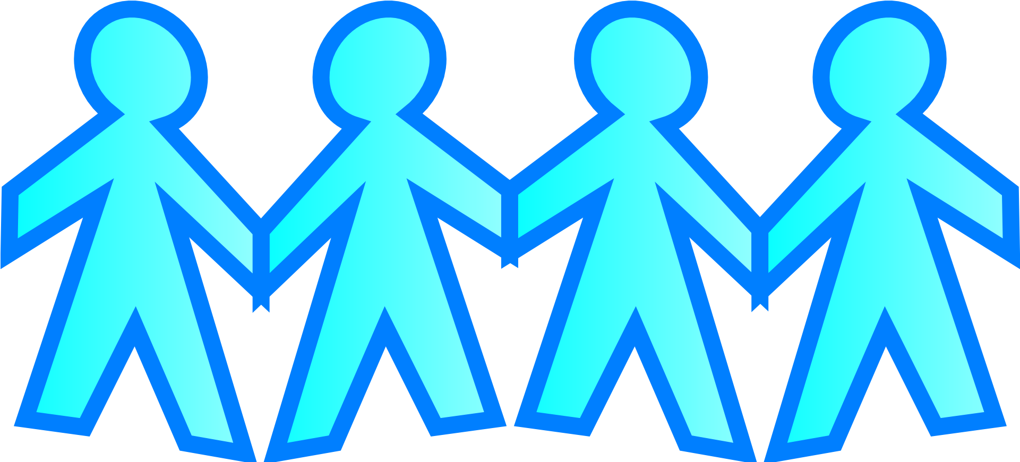

* VSLA is a group of people that meets in a safe place to save their money and get loans.

I can support my child to participate in a VSLA by…

***CONGRATULATIONS!***

You have completed all the Parents Meetings.



Draw in the bubbles what you enjoyed most about this group!

Other Notes

1. Infographic from the International Federation of the Red Cross and Red Crescent Societies. <https://www.ifrc.org/Global/Photos/Asia%20Pacific/GBV%20page/GBV%20infographic_FINAL3.pdf>
2. Infographic from World Health Organization on FGM: <https://www.who.int/reproductivehealth/publications/fgm/fgm-infographic-3.pdf?ua=1>.