

**PARTICIPANT BOOKLET**

**For Parents/Caretakers of Very Young Adolescents**

**(Ages 10-14)**

Global version designed for adaptation

May 2023

THIS BOOKLET BELONGS TO:

LOCATION OF THE PARENTS GROUP MEETINGS:

MEETING TIME:

IF YOU FOUND THIS BOOKLET, PLEASE RETURN TO ME.

MY CONTACT INFORMATION:

**SESSION 1: WELCOME AND INTRODUCTIONS**

FACTSHEET

Welcome to the Parents Participant Guide!

This Booklet is yours to keep. Inside, there is information about how you can support your children become happy, healthy adults.



* Teaches skills to empower **adolescent boys and girls** to become successful, healthy adults.
* Teaches **parents** how to support their adolescent children.

My Notes:

3 Factors

Adolescents need 3 things from YOU to grow up safe and healthy:

|  |  |
| --- | --- |
| 1. | Family connectedness |
| 2. | Close relationships with friends and peers |
| 3. | Education |

Tonight, share information about the Act With Her Program with someone in your home, such as your husband or wife.

I will share this with my .

**SESSION 2: CHANGING ROLES**

FACTSHEET + WORKSHEET

Today, we learned about GENDER and BIOLOGICAL SEX.

**Sex vs Gender**

Put a **X** if the picture has to do with GENDER or SEX.

|  |  |  |
| --- | --- | --- |
|  | Gender | Sex |
| 1.  Pregnant woman |  |  |
| 2.  Person cleaning |  |  |
| 3.  Caring for baby |  |  |

**SESSION 2: CHANGING ROLES (continued)**

FACTSHEET + WORKSHEET

* Gender roles and norms for boys and girls are **different**.
* This difference creates **inequalities** between boys and girls.
* It is important to support your child to **challenge** gender inequalities.

What else did you learn?

Goals for My Child



**What are your goals for your child?** DRAW.

|  |  |  |
| --- | --- | --- |
| **GOAL #1** | **GOAL #2** | **GOAL #3** |

**SESSION 2: CHANGING ROLES (continued)**

FACTSHEET + WORKSHEET

**How can you help your child to reach their goals?**

|  |
| --- |
|  |

**SESSION 3: SCHOOL – YOUR CHILD’S BEST FRIEND**

*JOURNAL ENTRY*

School is very important for your child!

Imagine your child once they finish school. Draw your vision here.

**MY CHILD:**



What else did you learn today?

What happens when a child is able to finish school?

Put an **X** next to each picture.

|  |  |
| --- | --- |
| They are happier! | Less emotional distress |
| Wait to have sex until they are ready | Other benefits? |

How will you keep your child in school?

**SESSION 4: TALKING TO YOUNG ADOLESCENTS ABOUT HEALTH AND SEX-RELATED TOPICS**

*FACTSHEET*

Adolescents are experiencing all kinds of physical and emotional changes right now!

**GIRLS**

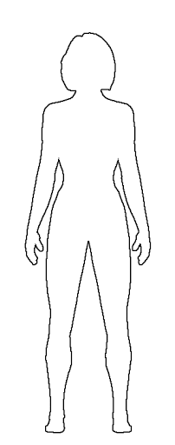

**Emotions:** Want to be more independent, spend less time with family and more time with friends. Can feel happy one minute and sad or angry the next.

**Skin:** Becomes oily, sometimes with pimples or acne

**Breasts**: Grow, swell and hurt just a little bit

**Sweat:** Perspiration increases, and body odor may appear

**Body size:** Hips widen, weight and height increases. Girls can reach full height before boys, but before puberty is finished boys will generally be taller than girls.

**Female sexual organs:** Period (menstruation) begins. Vaginal wetness increases, may have sexual feelings.

**Hair**: Hair increases on leg, under arms, and in pubic areas

**Motor functions:** May feel clumsy because your body is getting bigger and long and your brain needs to get used to it.

**SESSION 4: TALKING TO YOUNG ADOLESCENTS ABOUT HEALTH AND SEX-RELATED TOPICS (continued)**

*FACTSHEET*

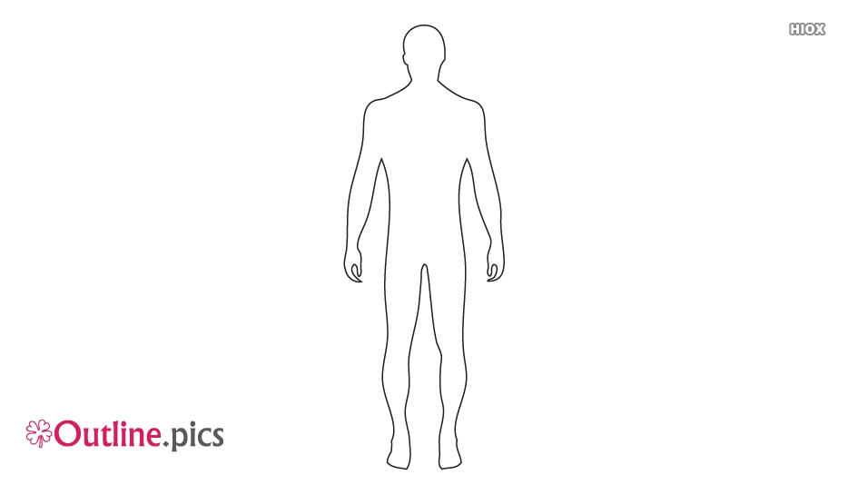**BOYS**

**Emotions:** Want to be more independent, spend less time with family and more time with friends. Can feel happy one minute and sad or angry the next.

**Skin:** Becomes oily, sometimes with pimples or acne

**Voice**: Will deepen and crack. It can go from high to low, this is normal.

**Sweat:** Perspiration increases, and body odor may appear

**Body size:** Shoulders and chest broaden. Weight and height increases. Boys will generally be taller than girls by end of puberty.

**Male sexual organs:** Wet dreams and erections occur, and penis and testicles grow larger. May have sexual feelings.

**Hair**: Hair increases on leg, under arms, and in pubic areas

**Motor functions:** May feel clumsy because your body is getting bigger and long and your brain needs to get used to it.

MENSTRUATION

* Is normal and natural!
* Is the shedding of tissue and blood from the vagina.
* Lasts between 4 to 7 days.
* Happens about once a month.

WHEN GIRLS FEEL PAIN FROM MENSTRUATION, THEY CAN:

|  |  |
| --- | --- |
| 1. Use a hot compress or take a pain reliever | https://lh5.googleusercontent.com/BGL5TWultSnc6z021qg8meo-PJ6ITwCyDWqgLqa1u0I3JevvRqoGVmIoH_3sasGiPbVka-lCiEajHNzrwF7XR_l1w4MvykdEsKYmAygzR4srXJ1RV2KjmZzU3JsbDvYFXtRff2JF    2. Relax! |
| https://lh6.googleusercontent.com/Ikwh_kp-ssYgWnPrUK_uToTcUDv794wid9FLuzxiABQo1UAvgzptMMzQZwQp7-9Fu23cWElDYHNn0w4tiV4Dv_J1C6XXu2_9GrVfdoE0g3XvpQLrK_s9lGIoxjvNQOmnQkXGVTl_  3. Drink tea | https://lh5.googleusercontent.com/vZhQnLFqJO248K9iErtRT_VYdbIkCY6Z-wgjuN5uO3IG3J665ASxq6L9HFqBA2kv6iUU3BVPwawIs0QD-UOVZeaW90qcDJ0jI5K76sVCSCUzZ0PcU0xH8NeusNlQkfkRuzARAxAd  4. Take a nap |
| https://lh6.googleusercontent.com/0pHirK8oXYNiIDfV58Sn1o5ScDtHQsoeBWw-r_0OM--WfOgcBtW4QiQU2O3fyFgnYC-wxUmM4ez0aucJ5YDh9YmMPbBTq0fKzhkBzuL7h6XXuoBgpOimEA9zw95_8mYipCHpj8Ut  5. If severe, go to the health clinic | |

**SESSION 4: TALKING TO YOUNG ADOLESCENTS ABOUT HEALTH AND SEX-RELATED TOPICS (continued)**

*FACTSHEET*

How Are Babies Made?

* Adolescent girls and women release an egg from the ovaries inside of them about once a month. This is called ovulation.
* Menstruation means that an adolescent girl has started to ovulate.
* Adolescent boys begin to produce sperm.
* When a man and woman have sex, the egg and sperm can meet.
* When the egg and sperm meet, they fuse together and become an embryo. This is called conception.
* The embryo becomes a fetus and grows in the uterus. After 9 months a baby is born.

My Notes:

Talk To Your Child About Sex and Health

|  |  |
| --- | --- |
| Step 1. | Pick a good time to talk. |
| Step 2. | When you talk, make them feel calm. Say, *“This is normal and natural.”* |
| Step 3. | Give them little bits of information at a time. |
| Step 4.  **???** | Ask if they have questions. |
| Step 5. | Keep the conversation short. |

**SESSION 5: STAYING SAFE**

*Journal Entry*

GENDER-BASED VIOLENCE (GBV)- When a more powerful gender inflicts violence on a less powerful gender. In most cases, it is men inflicting violence on women.[1]



Denial of resources, opportunities or services

Domestic violence

Forced trafficking and prostitution

Early marriage

Rape

Sexual, psychological and physical exploitation and abuse

What Parents Can Do

* Observe if your child does not want to go to school. Ask them why.
* Your child needs your love and support. Be open to talk.
* Emphasize GBV and sexual harassment is never their fault!
* Talk with your child about solutions. Take action.

If my child experiences GBV, I can …

**Places I Can Take My Child for GBV Support**

Name of Police Station / One Stop Center:

Name of Officer:

Address:

Phone Number:

Name of Clinic or Health Center:

Name of Provider:

Address:

Phone Number:

**SESSION 6: INEQUITABLE GENDER NORMS & PRACTICES**

*Factsheet*

Female Genital Cutting (FGC) is bad for girls’ health.[2]

**Complications with**

**the giving birth**

such as difficult labor



**Complications with**

**the body**

such as menstrual

problems or pelvic pain

**Sexual dysfunction**

such as painful intercourse

**Mental health disorders**

such as depression or anxiety

Other Notes

I will discuss this with

Child Marriage



Other Notes

***CONGRATULATIONS!***

You have completed all the Parents Meetings.



Draw in the bubbles what you enjoyed most about this group!

Other Notes

1. Infographic from the International Federation of the Red Cross and Red Crescent Societies. <https://www.ifrc.org/Global/Photos/Asia%20Pacific/GBV%20page/GBV%20infographic_FINAL3.pdf>
2. Infographic from World Health Organization on FGM: <https://www.who.int/reproductivehealth/publications/fgm/fgm-infographic-3.pdf?ua=1>.