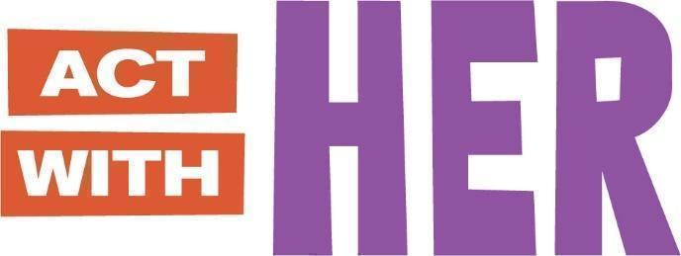

**PARTICIPANT BOOKLET**

**For Young Adolescent Boys’ Clubs**

**(Ages 10-14)**

Global version designed for adaptation

May 2023

THIS BOOKLET BELONGS TO:

MY MENTOR’S NAME IS:

IF YOU FOUND THIS BOOKLET, PLEASE RETURN TO ME.

THANK YOU!

**SESSION 1: WELCOME AND GOALS**

*JOURNAL ENTRY*

Today, we learned about ASPIRATIONS and GOALS.

* Aspirations are my dreams for the future.
* Goals have a deadline and will help me to reach my aspiration.

My aspiration is to:

**Education Goal #1:**

**Other Goal #2:**

**Other Goal #3:**

I (GUARDIAN / PARENT NAME) will support my child to reach their goals

**SESSION 2: I LOVE TO READ**

*JOURNAL ENTRY*

I shared what I learned in Session 1 with .

Today, we learned that it is important to practice reading.

**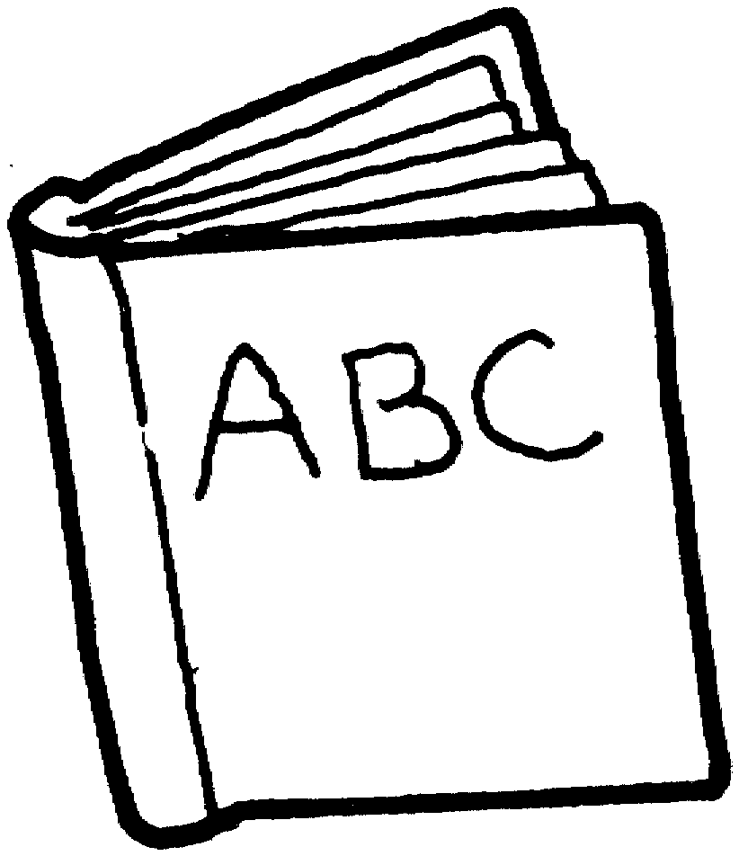MY FAVORITE BOOK!**

BOOK TITLE:

AUTHOR NAME:

I LIKE THIS BOOK BECAUSE:

**SESSION 2: I LOVE TO READ (Continued)**

*STORY – TORTOISE AND THE HARE*

|  |  |
| --- | --- |
|  | A hare and tortoise were talking one day.  The hare said, “I am the fastest runner in the forest and you are very slow. We should race!”  The tortoise said, “You are very fast, but I will win this race.” |
|  | The next day the tortoise and the hare stood next to a big tree, ready for the race.  “1, 2, 3, GO!”, said the hare and they started running. |
|  | The hare was ahead of the tortoise when he saw a field of cabbage. He looked back and did not see the tortoise.  He said, “I will eat here and still win the race!”  The hare was sleepy after his meal. He said, “I will sleep now. When I wake up I will still win the race!” |
|  | The sun was setting when the hare woke up. He looked around to see the tortoise a few steps from the finish line.  The hare ran to the finish line as fast as he could, but the tortoise already crossed, winning the race. “Slow and steady wins the race”, said the tortoise.  **The End.** |

**SESSION 3: OUR CHANGING BODIES**

*JOURNAL ENTRY*

Today, we learned about CHANGES IN THE BODY DURING PUBERTY.

**GIRLS**

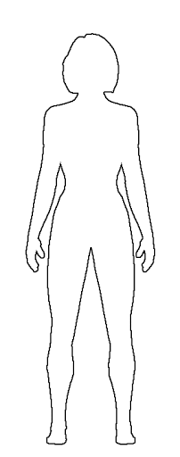

**Emotions:** Want to be more independent, spend less time with family and more time with friends. Can feel happy one minute and sad or angry the next.

**Skin:** Becomes oily, sometimes with pimples or acne

**Breasts**: Grow, swell and hurt just a little bit

**Sweat:** Perspiration increases, and body odor may appear

**Body size:** Hips widen, weight and height increases. Girls can reach full height before boys, but before puberty is finished boys will generally be taller than girls.

**Female sexual organs:** Period (menstruation) begins. Vaginal wetness increases, may have sexual feelings.

**Hair**: Hair increases on leg, under arms, and in pubic areas

**Motor functions:** May feel clumsy because your body is getting bigger and long and your brain needs to get used to it.

**SESSION 3: OUR CHANGING BODIES (Continued)**

*FACTSHEET*

**BOYS**

*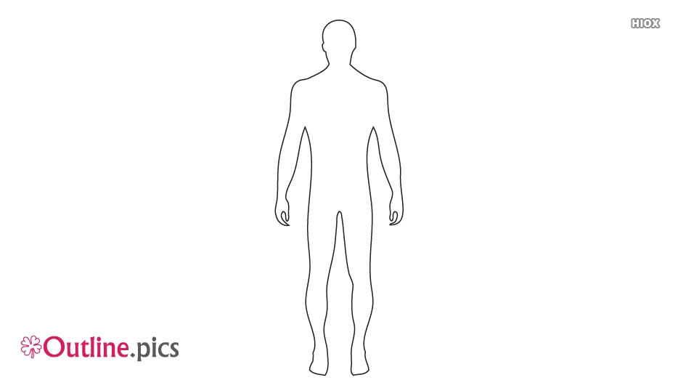*

**Emotions:** Want to be more independent, spend less time with family and more time with friends. Can feel happy one minute and sad or angry the next.

**Skin:** Becomes oily, sometimes with pimples or acne

**Voice**: Will deepen and crack. It can go from high to low, this is normal.

**Sweat:** Perspiration increases, and body odor may appear

**Body size:** Shoulders and chest broaden. Weight and height increases. Boys will generally be taller than girls by end of puberty.

**Male sexual organs:** Wet dreams and erections occur, and penis and testicles grow larger. May have sexual feelings.

**Hair**: Hair increases on leg, under arms, and in pubic areas

**Motor functions:** May feel clumsy because your body is getting bigger and long and your brain needs to get used to it.

**SESSION 4: WHERE DO BABIES COME FROM?**

*JOURNAL ENTRY*

Today, we learned how babies are made and how to prevent pregnancy.

* The #1 way to prevent pregnancy is to not have sex.
* Other ways to prevent pregnancy are contraceptive methods

|  |  |
| --- | --- |
| Male and Female Condoms | Contraceptive Pills |
| Injectables  Injection Needle_black | IUDs  IUD_black |
|  | |

**SESSION 5: GENDER AND SOCIETAL EXPECTATIONS**

*WORKSHEET*

Today, we learned about GENDER and BIOLOGICAL SEX. I also learned .

**Sex vs Gender**

Put an **X** if the picture has to do with GENDER or SEX.

|  |  |  |
| --- | --- | --- |
|  | Gender | Sex |
| 1.  Pregnant woman |  |  |
| 2.  Person cleaning |  |  |
| 3.  Caring for baby |  |  |

**SESSION 6: WHOSE ROLE IS IT? (JOINT SESSION)**

*JOURNAL ENTRY*

Today, we learned that boys and girls can do the same things!

* Boys can cook, care for children, and clean.
* Girls can herd sheep, raise cows, and become an engineer.

I also learned…

This is what it looks like when boys and girls share housework together.

|  |
| --- |
|  |

I will talk with in my family to share what I learned about gender roles.

**SESSION 7: GOOD COMMUNICATION SKILLS**

*JOURNAL ENTRY*

I shared what I learned in Session 6 with .

Draw what **good body language** looks like!

|  |
| --- |
|  |

This is GOOD COMMUNICATION because…

Draw what **bad body language** looks like!

|  |
| --- |
|  |

This is bad communication because…

**SESSION 8: GOOD DECISION-MAKING**

*JOURNAL ENTRY*

Today, we learned about how to make GOOD DECISIONS.

It is normal for boys like me to feel lots of emotions. I also learned

When I feel strong emotions such as anger or sadness, I will:





**1. STOP 2. THINK**

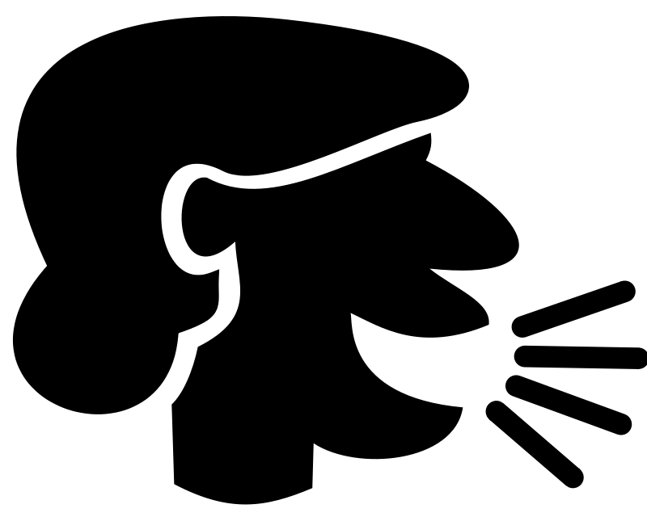

**3. THEN SPEAK**

Remember: I can always walk away if I cannot do these steps.

**SESSION 9: MOVE, GROW, SHINE – NUTRITION FOR TEEN BOYS**

*FACTSHEET + JOURNAL ENTRY*

Today, we learned about MOVE, GROW, and SHINE foods to keep our bodies healthy.

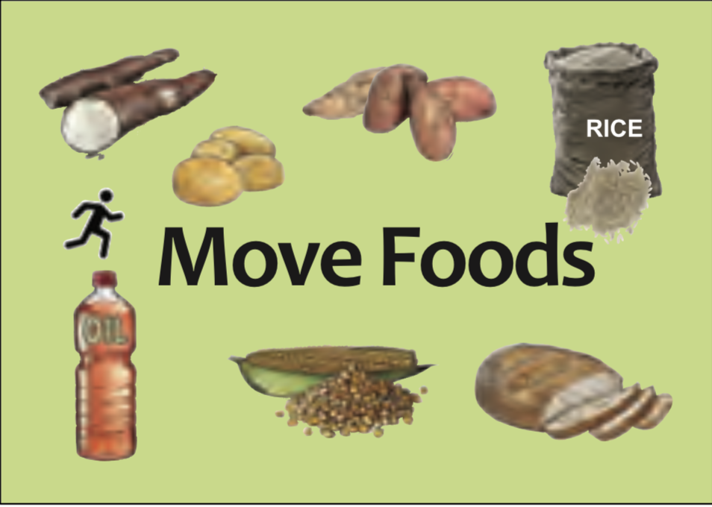

**Move Foods**

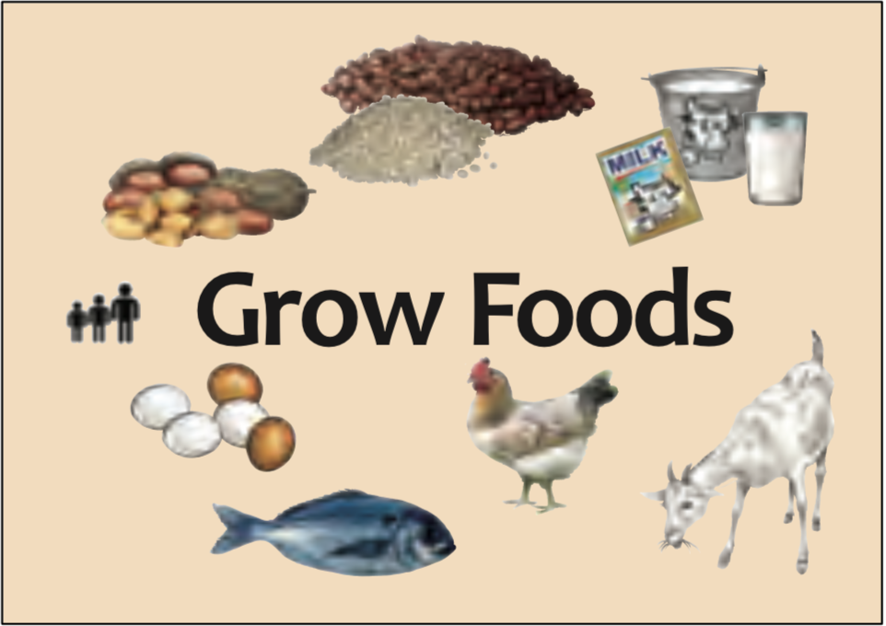

**Grow Foods**

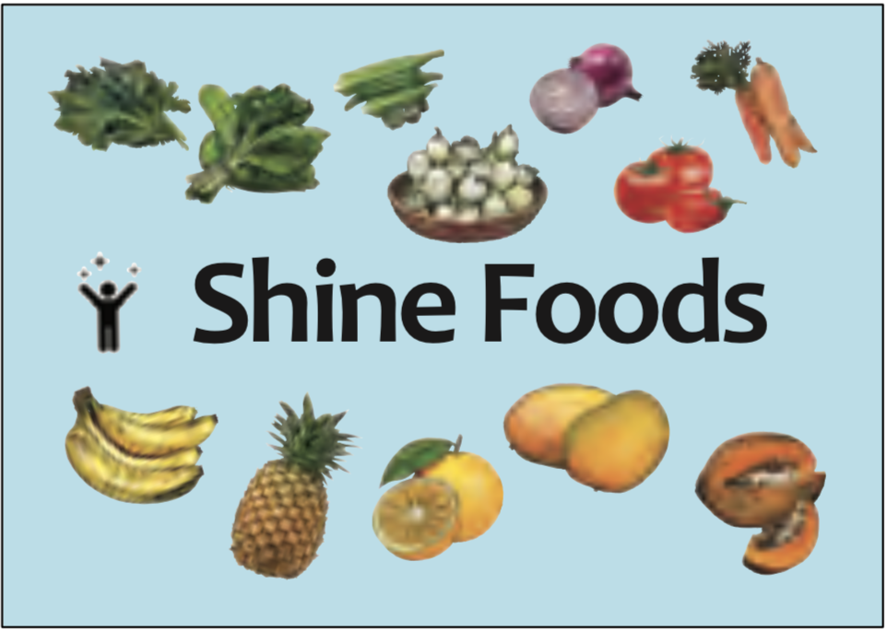

**Shine Foods**

I also learned…

**SESSION 9: MOVE, GROW, SHINE – NUTRITION FOR TEEN BOYS (Continued)**

*FACTSHEET + JOURNAL ENTRY*



Draw what Move, Grow, and Shine foods you want on your plate!

**SESSION 10: MY GOALS REVISITED**

*JOURNAL ENTRY*

I shared what I learned in Session 9 with .

Have I reached my goals from Session 1? Put an **X** next to your answer.

Goal # 1?

|  |  |
| --- | --- |
| * YES | * NO |
|  |  |

Goal #2?

|  |  |
| --- | --- |
| * YES | * NO |
|  |  |

**SESSION 10: MY GOALS REVISITED** (Continued)

*JOURNAL ENTRY*

If **NO**, this is my plan to reach my goals:

This week I can…

Next week I can…

Next month I can…

If **YES**, my new goal is

**NEW GOAL:**

**SESSION 11: NEGOTIATING SKILLS FOR BOYS AND GIRLS (JOINT SESSION)**

*JOURNAL ENTRY*

Today, we learned the 4 NEGOTIATION SKILLS. We practiced our negotiating skills with boys and girls.

|  |  |
| --- | --- |
| STEP 1 | Establish ground rules for yourself.  https://lh4.googleusercontent.com/jH9Hfl2OISV13mOXuJm_YCWCweqW2lpVHls5NiPf6RPm6c8Ehko6_TthQaZF5brKR7SI5V-kC5BnnZJTyW-ruya9WQ44NOth1PzDWA9pJLkFp1L6Crn3C2kk9G9nHl3nTXVr275_ |
| STEP 2 | State what you want and why.  https://lh4.googleusercontent.com/ZTmQgzUnItA3DtBhyHr_iDNZeMPCuSeYinPynUg5Hx7UI58XRL-iprKoacQd9ZQv1Uk7caBjYhHR_vxNy2TwqMPmEBhfCBNftPaxRMRZjglXakwdFVAAfzsiPMa4fEtYlnwtPiEI |
| STEP 3 | Brainstorm solutions. |
| STEP 4 | Come to an agreement. |

Draw a picture of what happened today.

|  |
| --- |
|  |

**SESSION 12: MODEL MEN IN THE COMMUNITY**

*JOURNAL ENTRY*

Today, we met a Model Man from the community.

His name was…

I liked his story because…

He reminded me of my Goal Number

I learned…

After I finish school, I will earn money by…

I want to be a Model Man because…

**SESSION 13: STAY IN SCHOOL / RETURN TO SCHOOL**

*JOURNAL ENTRY*

I shared what I learned in Session 12 with .

Today, we learned it is important to stay in school.

Fill in the circle with names or drawings of people who you can go to if you need help to stay in school.

**SESSION 14: GENDER, VIOLENCE, AND INEQUITABLE GENDER NORMS & PRACTICES**

*JOURNAL ENTRY*

I shared what I learned in Session 13 with .

* Today, we learned that Female Genital Cutting (FGC) is bad for girls’ health.[[1]](#footnote-1)



**Complications with**

**the body**

such as menstrual

problems or pelvic pain

**Complications with**

**the giving birth**

such as difficult labor

**Sexual dysfunction**

such as painful intercourse

**Mental health disorders**

such as depression or anxiety

* Today, we learned that Sexual harassment and rape is never a girl’s fault! [[2]](#footnote-2)



Denial of resources, opportunities or services

Forced trafficking and prostitution

Domestic violence

Early marriage

Rape

Sexual, psychological and physical exploitation and abuse

**SESSION 14: GENDER, VIOLENCE, AND INEQUITABLE GENDER NORMS & PRACTICES (Continued)**

* Today, we learned about child marriage.



**SESSION 14: GENDER, VIOLENCE, AND INEQUITABLE GENDER NORMS & PRACTICES (Continued)**

* Here are important SAFETY SKILLS to protect myself.

|  |  |
| --- | --- |
| **Safety Skills:** | **Examples:** |
| https://lh3.googleusercontent.com/07wGTOtTaFZBdya29dNLeqQ7e8el1djcTjhc_XtsCi07F2uTlMu_n2IQ4TG9xg6orpyr_SuzkT-BU8I50asbU1wcQ-Yb5S040qoRuAaeILHsw3LQ0-CP1R1dusED4P3vZJ0Pi6rRSay clearly what you want. | * Simple: “No, thanks”, or “No” * Strong: “No!” “Don’t do that!” * Again and again: “No, no, **NO!!!**” |
| https://lh5.googleusercontent.com/srEGHMUH4VyRKevJwjRlCedokEnKjXODt5jjEmf4sVXifOjpPpDHi7WgfvrtatfG0lNenJMgO4ACtjemrp4X3Q3VbaYW-YNzLqt7eIZrjS1H9u9Na9w0i7LTGefJanftRezaB_qA  Be loud! | * Talk in a loud voice. * Scream for help if you feel you are at risk. |
| https://lh6.googleusercontent.com/WObrtH7NezM8HpRioZe08qrz35Ey2soAAPyi5HWUsBgRpRw_nvHjnlIkVzGyTGAxUh-blpyDpv9VYxld6xkqaOd-VRQuSkev_vZffsqOdZZ_UfFK57XclnTTUxOLd9LUsB2a1887Create distance. | * Push the person away without smiling and walk away. * Leave and go somewhere safe. |
| Stay away. | * If you think you will be pressured, don’t go with the person. * Avoid being alone with a date or new boyfriend until you trust them. |
| https://lh3.googleusercontent.com/at_MRzA6ATn2ehXb1jlusCqqoAc6RBStsqInqDNowuL6m-L8JWN7EmjWfLKaoUJpYA9_jiao75tM6gP6M9EhMR-yuDeKr6K8L53yiryE6aLtfaiTfS2HLHqRArIPh3ALkN5VeY8tSafety in numbers. | * Walk with a group of friends or family members. Keep trusted friends nearby. * Always tell someone where you are going. |
| https://lh3.googleusercontent.com/m6BNWnGj0UsBfZA0X7JkUPEFrYsjODZqOSHTSt8-Dr5TkNXe7QEbPXD8ub1d8Jn4SoCNsjkGDEOyG3Q0gRqcoozFiNCQdyb9b0ezf6cqr2NHkkq8zLrHFXotQsa0uh97_YCz7AB8  Call in support | Say you will tell somebody with power such as parents, counselors, relatives, and police. |

One person I will share this information with is

**SESSION 15: WHO AM I?**

*FACTSHEET*

I shared what I learned in Session 14 with .

Today, we learned about GENDER IDENTITY, and GENDER EXPRESSION, SEXUAL ORIENTATION.

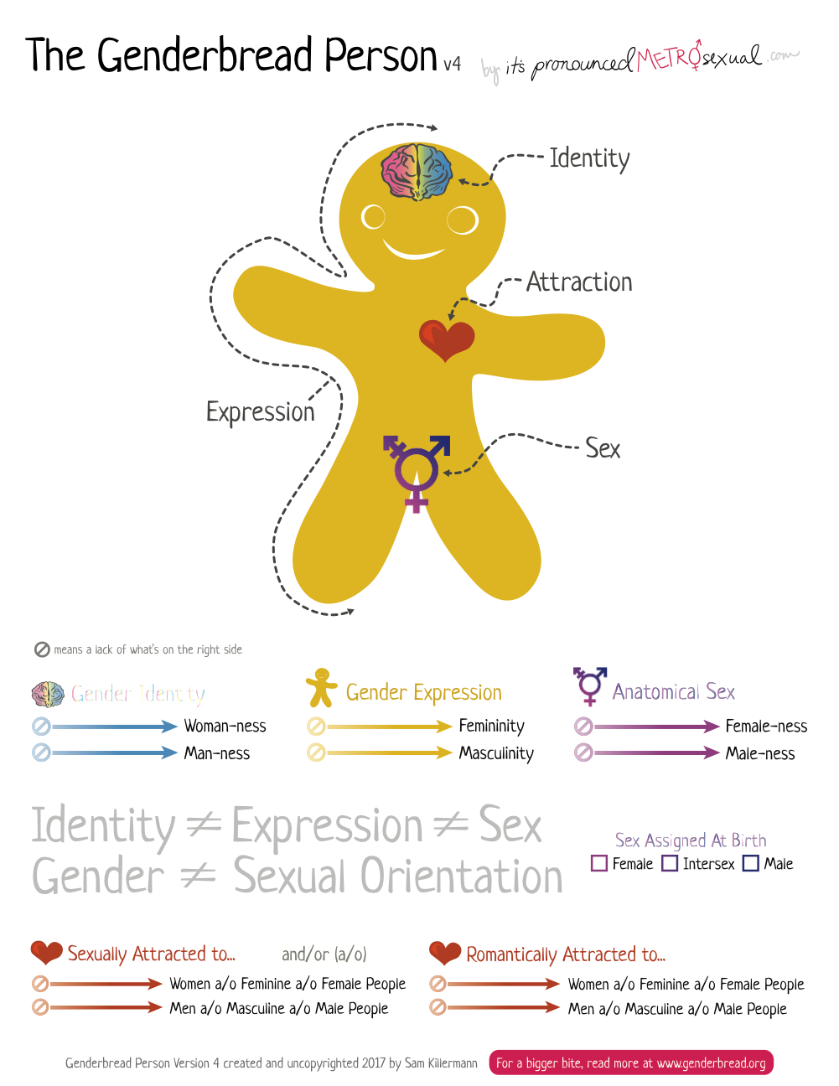

**SESSION 16: CHANGING GENDER ROLES (JOINT SESSION)**

*JOURNAL ENTRY*

Today, we learned about how GENDER ROLES change over time.

In the box, draw activities both boys *AND* girls can do.

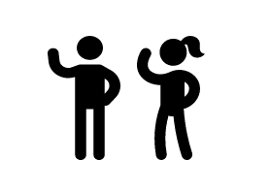

**SESSION 17: SEXUALLY TRANSMITTED INFECTIONS**

*FACTSHEET*

I shared what I learned in Session 16 with .

Today, we learned about SEXUALLY TRANSMITTED INFECTIONS (STIs), including HIV.

***What are STIs?***

STIs are infections usually spread from person to person through sexual activity. Some STIs can also be spread through sharing needles.

Two common STIs are Gonorrhea and Chlamydia. These are bacterial infections.

Three other common STIs are the Human Papilloma Virus (HPV) genital herpes, and the Human Immunodeficiency Virus (HIV). These are viral infections.

***How do I know if I have an STI?***

You may feel:

* A vaginal discharge –more than normal - and that has an odor
* Sores on the vagina
* Bumps on the vulva

Some STIs have no symptoms at all!

Check with a health care provider if you have unprotected sex.

**SESSION 17: SEXUALLY TRANSMITTED INFECTIONS (continued)**

*FACT SHEET*

***What is HIV?***

HIV stands for Human Immunodeficiency Virus. It **cannot** be cured with medicine.

It is spread through:

* Having sex with someone who is infected with HIV
* Exposed to blood with HIV (e.g. blood transfusions, sharing needles)
* During pregnancy and childbirth if the mother has HIV

***How can I protect myself from STIs?***

* Do not have sex
  + Do not share sharp instruments
  + Get vaccinated for HPV
  + Using condoms correctly and every time when you decide to have sex.
  + When you decide to have sex, get tested regularly.

I also learned…

**SESSION 18: MY MONEY, MY PLAN**

*JOURNAL ENTRY*

**$$**

Today, we learned about SAVING MONEY.

My picture of what I will buy when I save enough money.

|  |
| --- |
|  |

To save money, I will…

1.

2.

3.

I will save my money in a SAFE PLACE.

**SESSION 19: STAYING SAFE IN THE COMMUNITY**

*WORKSHEET*

Today, we learned how to do a RISK ASSESSMENT and ACTION PLAN. I also learned

Match the sentence with the picture!

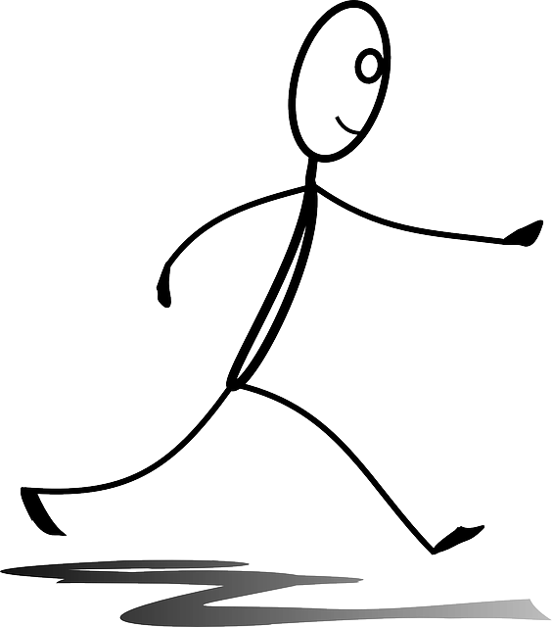

|  |
| --- |
| *Example:*  Banana |
| 1. Learn about the risky areas in your area. |
| 2. Make a plan to stay safe. |
| 3. Walk with confidence. |
| 4. Watch and observe what is around you at all times. |

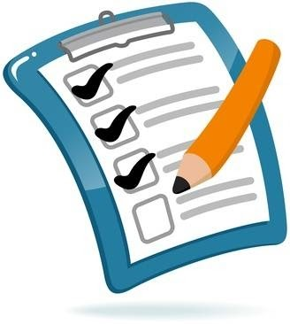

**SESSION 20: COMMUNITY MAPPING AND SAFETY**

*JOURNAL ENTRY*

Today, we learned about how to keep the community safe for everyone.

If I need help to be safe, I can go to…

* Circle as many people that you can go to.

|  |  |  |
| --- | --- | --- |
| My mother | My father | My auntie |
| My uncle | My friend | My teacher |
| A representative of women’s rights | Community leader | The police |
| My brother | My sister |  |

This is a picture of my community when it is safe for both boys and girls!

|  |
| --- |
|  |

**SESSION 21: WRAP UP AND NEXT STEPS**

*JOURNAL ENTRY*

***CONGRATULATIONS!***

You have learned so much!



Draw in the bubbles below what you have learned about each topic.

**Finance**

**Gender**

**Education**

**Health**

**Safety from Violence**

**Communication**

1. Infographic from World Health Organization on FGM: <https://www.who.int/reproductivehealth/publications/fgm/fgm-infographic-3.pdf?ua=1>. [↑](#footnote-ref-1)
2. Infographic from the International Federation of the Red Cross and Red Crescent Societies. <https://www.ifrc.org/Global/Photos/Asia%20Pacific/GBV%20page/GBV%20infographic_FINAL3.pdf> [↑](#footnote-ref-2)