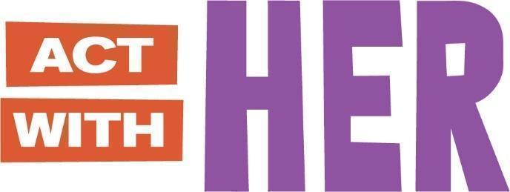

**PARTICIPANT BOOKLET**

**For Young Adolescent Girls’ Clubs**

**(Ages 10-14)**

Global version designed for adaptation

May 2023

THIS BOOKLET BELONGS TO:

MY MENTOR’S NAME IS:

IF YOU FOUND THIS BOOKLET, PLEASE RETURN TO ME.

THANK YOU!

**SESSION 1: WELCOME AND INTRODUCTIONS**

*JOURNAL ENTRY*

Welcome to your Booklet!

Today we learned about SELF-ESTEEM. Good self-esteem means you feel good about yourself. You love and respect yourself and others.



I also learned…

**SESSION 2: ASPIRATIONS AND GOALS**

*JOURNAL ENTRY*

Today, we learned about ASPIRATIONS and GOALS.

* Aspirations are my dreams for the future.
* Goals have a deadline and will help me to reach my aspiration.

My aspiration is to:

**Education Goal #1:**

**Other Goal #2:**

**Other Goal #3:**

I (GUARDIAN / PARENT NAME) will support my child to reach their goals!

**SESSION 3: I LOVE TO READ**

*JOURNAL ENTRY*

I shared what I learned in Session 2 with .

Today, we learned that it is important to practice reading.

MY FAVORITE BOOK!

BOOK TITLE:

AUTHOR NAME:

I LIKE THIS BOOK BECAUSE:

**SESSION 3: I LOVE TO READ (Continued)**

*READ WITH US – THE TORTOISE AND THE HARE*

|  |  |
| --- | --- |
|  | A hare and tortoise were talking one day.  The hare said, “I am the fastest runner in the forest and you are very slow. We should race!”  The tortoise said, “You are very fast, but I will win this race.” |
|  | The next day the tortoise and the hare stood next to a big tree, ready for the race.  “1, 2, 3, GO!”, said the hare and they started running. |
|  | The hare was ahead of the tortoise when he saw a field of cabbage. He looked back and did not see the tortoise.  He said, “I will eat here and still win the race!”  The hare was sleepy after his meal. He said, “I will sleep now. When I wake up I will still win the race!” |
|  | The sun was setting when the hare woke up. He looked around to see the tortoise a few steps from the finish line.  The hare ran to the finish line as fast as he could, but the tortoise already crossed, winning the race. “Slow and steady wins the race”, said the tortoise.  **The End.** |

**SESSION 4: OUR CHANGING BODIES – PART 1**

*FACT SHEET*

Today, we learned about the CHANGES IN THE BODY DURING PUBERTY.[[1]](#footnote-2)

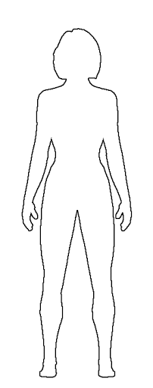

**Emotions:** Want to be more independent, spend less time with family and more time with friends. Can feel happy one minute and sad or angry the next.

**Skin:** Becomes oily, sometimes with pimples or acne

**Breasts**: Grow, swell and hurt just a little bit

**Sweat:** Perspiration increases, and body odor may appear

**Body size:** Hips widen, weight and height increases. Girls can reach full height before boys, but before puberty is finished boys will generally be taller than girls.

**Female sexual organs:** Period (menstruation) begins. Vaginal wetness increases, may have sexual feelings.

**Hair**: Hair increases on leg, under arms, and in pubic areas

**Motor functions:** May feel clumsy because your body is getting bigger and long and your brain needs to get used to it.

**SESSION 4: OUR CHANGING BODIES – PART 1 (continued)**

*FACT SHEET*

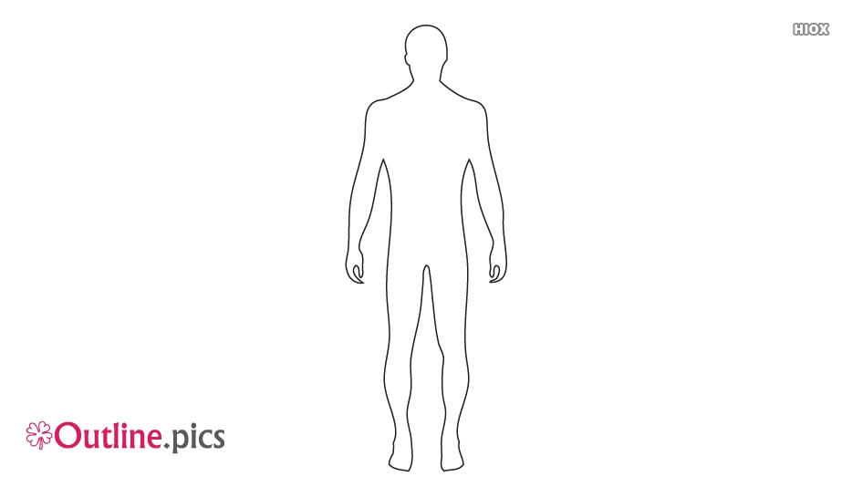

**Emotions:** Want to be more independent, spend less time with family and more time with friends. Can feel happy one minute and sad or angry the next.

**Skin:** Becomes oily, sometimes with pimples or acne

**Voice**: Will deepen and crack. It can go from high to low, this is normal.

**Sweat:** Perspiration increases, and body odor may appear

**Body size:** Shoulders and chest broaden. Weight and height increases. Boys will generally be taller than girls by end of puberty.

**Male sexual organs:** Wet dreams and erections occur, and penis and testicles grow larger. May have sexual feelings.

**Hair**: Hair increases on leg, under arms, and in pubic areas

**Motor functions:** May feel clumsy because your body is getting bigger and long and your brain needs to get used to it.

**SESSION 5: OUR CHANGING BODIES – PART 2**

*JOURNAL ENTRY*

Today, we learned about MENSTRUATION!

MENSTRUATION

* Is normal and natural!
* Is the shedding of tissue and blood from the vagina.
* Lasts between 4 to 7 days.
* Happens about once a month.

I also learned…

If I have questions about the changes in my body or menstruation, I will ask:

**SESSION 5: OUR CHANGING BODIES – PART 2 (CONTINUED)**

*JOURNAL ENTRY*

When I feel pain from menstruation I can…

|  |  |
| --- | --- |
| 1. Use a hot compress or take a pain reliever | https://lh5.googleusercontent.com/BGL5TWultSnc6z021qg8meo-PJ6ITwCyDWqgLqa1u0I3JevvRqoGVmIoH_3sasGiPbVka-lCiEajHNzrwF7XR_l1w4MvykdEsKYmAygzR4srXJ1RV2KjmZzU3JsbDvYFXtRff2JF    2. Relax! |
| https://lh6.googleusercontent.com/Ikwh_kp-ssYgWnPrUK_uToTcUDv794wid9FLuzxiABQo1UAvgzptMMzQZwQp7-9Fu23cWElDYHNn0w4tiV4Dv_J1C6XXu2_9GrVfdoE0g3XvpQLrK_s9lGIoxjvNQOmnQkXGVTl_  3. Drink tea | https://lh5.googleusercontent.com/vZhQnLFqJO248K9iErtRT_VYdbIkCY6Z-wgjuN5uO3IG3J665ASxq6L9HFqBA2kv6iUU3BVPwawIs0QD-UOVZeaW90qcDJ0jI5K76sVCSCUzZ0PcU0xH8NeusNlQkfkRuzARAxAd  4. Take a nap |
| https://lh6.googleusercontent.com/0pHirK8oXYNiIDfV58Sn1o5ScDtHQsoeBWw-r_0OM--WfOgcBtW4QiQU2O3fyFgnYC-wxUmM4ez0aucJ5YDh9YmMPbBTq0fKzhkBzuL7h6XXuoBgpOimEA9zw95_8mYipCHpj8Ut  5. If severe, go to the health clinic | |

**SESSION 6: WHERE DO BABIES COME FROM?**

*FACTSHEET + JOURNAL ENTRY*

Today, we learned how babies are made and how to prevent pregnancy.

* The #1 way to prevent pregnancy is do not have sex.
* When I am ready to have sex, other ways to prevent pregnancy are by contraceptive methods.

|  |  |
| --- | --- |
| Male or Female Condoms | Contraceptive Pills |
| Injection Needle_blackInjectables | IUD_blackIUD (intrauterine device) |

I also learned…

**SESSION 7: GENDER AND SOCIETAL EXPECTATIONS**

*FACT SHEET*

Today, we learned about GENDER and BIOLOGICAL SEX. I also learned .

**Sex vs Gender**

Put an **X** if the picture has to do with GENDER or SEX.

|  |  |  |
| --- | --- | --- |
|  | Gender | Sex |
| 1.  Pregnant woman |  |  |
| 2.  Person cleaning |  |  |
| 3.  Caring for baby |  |  |

**SESSION 8: INEQUITABLE GENDER NORMS & PRACTICES**

*FACTSHEET + JOURNAL ENTRY*

Today, we learned that FEMALE GENITAL CUTTING (FGC) is bad for girls’ health! [[2]](#footnote-3)

**Complications with**

**the giving birth**

such as difficult labor

**Complications with**

**the body**

such as menstrual

problems or pelvic pain

**Sexual dysfunction**

such as painful intercourse

**Mental health disorders**

such as depression or anxiety

I also learned…

**SESSION 8: INEQUITABLE GENDER NORMS & PRACTICES (CONTINUED)**

*FACTSHEET + JOURNAL ENTRY*

We also learned about CHILD MARRIAGE.



If I need help, I will ask

**SESSION 9: GENDER AND VIOLENCE**

*FACTSHEET*

* GENDER-BASED VIOLENCE IS NEVER a girl’s fault![[3]](#footnote-4)

What are the types of GBV?



Rape

Early marriage

Domestic violence

Forced trafficking and prostitution

Denial of resources, opportunities or services

Sexual, psychological and physical exploitation and abuse

* Here are important SAFETY SKILLS to protect myself.

|  |  |
| --- | --- |
| **Safety Skill:** | **Examples:** |
| Say clearly what you want. | * Simple: “No, thanks”, or “No” * Strong: “No!” “Don’t do that!” * Again and again: “No, no, **NO!!!**” |
| https://lh4.googleusercontent.com/TQw8kRQqrzld8-mYiQ0iOd0DXtDOHjg79CmmpVet52vw5SuMMiCdd8uKCe6WFY_FvQDY0hizVhfQ65v02q5m59KPvkbZrzlyrN8rEl0J5N92Fx4fLrf4PmoCPxArS1ORwgPP6qDO  Be loud! | * Talk in a loud voice. * Scream for help if you feel you are at risk. |
| https://lh6.googleusercontent.com/a7_pZsDoJWWpfZHt1OreCyTfrEDteZ4stpEALAsAYr-QJRMq-bzpTH9NHu8y9GzbBHI9n-SL91RI7o-wxLh13gqcsvLhayMXRy2SD0EdFcIw91geA5Epg8mUraeW4oaf683_NYQI  Create distance. | * Push the person away without smiling and walk away. * Leave and go somewhere safe. |
| Stay away. | * If you think you will be pressured, don’t go with the person. * Avoid being alone with a date or new boyfriend until you trust them. |
| https://lh6.googleusercontent.com/JJcWharftLCIz8Dz6jAM9wlmxCYa7EEkwMTpYKkUxIfWkMrRfoLfLst2lTgn5INllbagPQjgJ6SJv2gcqmg3w-9O55JiZd_GXbRYY0ZqHgloS7m0SKNHL3H2MSPRo-dLWaOAnT3_  Safety in numbers. | * Walk with a group of friends or family members. Keep trusted friends nearby. * Always tell someone where you are going. |
| https://lh5.googleusercontent.com/XqzQbaW9l3k4UwbWH-WiGYC20AAWp6-5mcRGcvwOL43BG36e8vZ0C20vVCZPcudTNWaQWNtxr7ER_-yNonBYXgpuqwsGRJZr-eVOjrkkfiQVfDgf0Gz7wjpPQ552sGRXOZHujAl5  Call in support. | Say you will tell somebody with power such as parents, counselors, relatives, and police. |

**SESSION 10: STAY IN SCHOOL / RETURN TO SCHOOL**

*JOURNAL ENTRY*

Today, we learned it is important to stay in school.

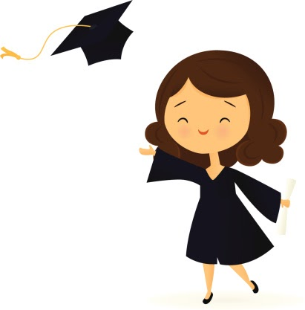Fill in the circle with names or drawings of people who you can go to if you need help to stay in school.

**SESSION 11: OVERCOMING BARRIERS TO EDUCATION**

*FACTSHEET + JOURNAL ENTRY*

Today, we learned the importance of 4 NEGOTIATION SKILLS to have more time to study and get help with household chores.

|  |  |
| --- | --- |
| STEP 1 | Establish ground rules for yourself.  https://lh4.googleusercontent.com/jH9Hfl2OISV13mOXuJm_YCWCweqW2lpVHls5NiPf6RPm6c8Ehko6_TthQaZF5brKR7SI5V-kC5BnnZJTyW-ruya9WQ44NOth1PzDWA9pJLkFp1L6Crn3C2kk9G9nHl3nTXVr275_ |
| STEP 2 | State what you want and why.  https://lh4.googleusercontent.com/ZTmQgzUnItA3DtBhyHr_iDNZeMPCuSeYinPynUg5Hx7UI58XRL-iprKoacQd9ZQv1Uk7caBjYhHR_vxNy2TwqMPmEBhfCBNftPaxRMRZjglXakwdFVAAfzsiPMa4fEtYlnwtPiEI |
| STEP 3 | Brainstorm solutions. |
| STEP 4 | Come to an agreement. |

How will you use your negotiation skills?

**SESSION 12: MODEL WOMEN IN THE COMMUNITY (PART 1)**

*JOURNAL ENTRY*

Today, we met a Model Woman from the community.

Her name was…

I liked her story because…

I learned…

After I finish school, I will earn money by…

I want to be a Model Woman because…

**SESSION 13: WHOSE ROLE IS IT? (JOINT SESSION)**

*JOURNAL ENTRY*

Today, we learned that boys and girls can do the same things!

* Boys can cook, care for children, and clean.
* Girls can herd sheep, raise cows, and become an engineer.

I also learned…

This is what it looks like when boys and girls share housework together.

|  |
| --- |
|  |

I will talk with in my family to share what I learned about gender roles.

**SESSION 14: MY GOALS REVISITED – PART 1**

*JOURNAL ENTRY*

I shared what I learned in Session 13 with .

Have I reached my 2 goals? Put an **X** next to your answer.

|  |  |
| --- | --- |
| * YES | * NO |

If **NO**, this is my plan to reach my goals:

This week I can…

Next week I can…

Next month I can…

If **YES**, my new goal is:

**NEW GOAL:**

**SESSION 15: SAY IT WELL – VERBAL COMMUNICATION**

*JOURNAL ENTRY*

Today, we learned about how to ask OPEN-ENDED QUESTIONS to have good communication.

|  |  |
| --- | --- |
| WHO? | WHAT? |
| WHERE? | WHY? |

I also learned…

What kinds of questions do your family members ask?

I can ask better questions by…

**SESSION 16: WHAT YOU DON’T SAY – NON-VERBAL COMMUNICATION**

*JOURNAL ENTRY*

Today, we learned about the importance of good body language.

Draw what **good body language** looks like!

|  |
| --- |
|  |

This is GOOD COMMUNICATION because…

Draw what **bad body language** looks like!

|  |
| --- |
|  |

This is bad communication because…

**SESSION 17: ARE YOU LISTENING?**

*JOURNAL ENTRY*

Today, we learned about ACTIVE LISTENING.

ACTIVE LISTENING means…

* Having good body language
* Paying attention
* Be neutral

Practice ACTIVE LISTENING with 1 family member or friend.

Draw a picture of what happened.

|  |
| --- |
|  |

**SESSION 18: MODEL WOMEN IN THE COMMUNITY – PART 2**

*JOURNAL ENTRY*

Today, we met a Model Woman from the community.

Her name was…

I liked her story because…

This is me as a Model Woman.

|  |
| --- |
|  |

**SESSION 19: MY MONEY, MY PLAN**

*JOURNAL ENTRY*

Today, we learned about SAVING MONEY.

My picture of what I will buy when I save enough money.

|  |
| --- |
|  |

To save money, I will…

1.

2.

3.

I will save my money in a SAFE PLACE.

**SESSION 20: HARASSMENT AND WAYS TO AVOID IT**

*WORKSHEET*

Today, we learned about HARASSMENT and reviewed our SAFETY SKILLS.



Can you remember the 6 safety skills? Draw!

|  |  |  |
| --- | --- | --- |
| 1. | 2. | 3. |
| 4. | 5. | 6. |

My favorite safety skill is…

I will share what I learned with…

**SESSION 21: STAYING SAFE IN THE COMMUNITY**

*WORKSHEET*

Today, we learned how to do a RISK ASSESSMENT and ACTION PLAN. I also learned

Match the sentence with the picture!

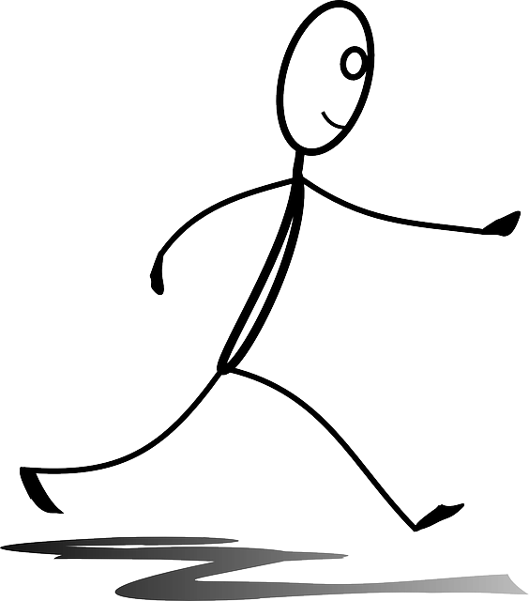

|  |
| --- |
| *Example:*  Banana |
| 1. Learn about the risky areas in your area. |
| 2. Make a plan to stay safe. |
| 3. Walk with confidence. |
| 4. Watch and observe what is around you at all times. |







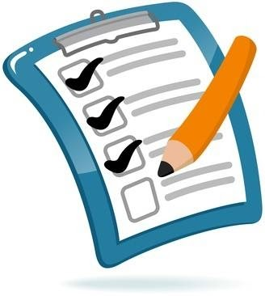

**SESSION 22: MAPPING RISKS AND SAFETY PLAN**

*JOURNAL ENTRY*

Today, we created a plan for staying safe in my community.

**MY SAFETY PLAN**

I feel unsafe when I go to \_\_\_\_\_\_\_\_\_\_\_\_\_\_\_\_\_\_\_\_\_\_\_\_\_\_.

I plan to stay safe by \_\_\_\_\_\_\_\_\_\_\_\_\_\_\_\_\_\_\_\_\_\_\_\_\_\_\_ and

\_\_\_\_\_\_\_\_\_\_\_\_\_\_\_\_\_\_\_\_\_.

If I need help, I will ask \_\_\_\_\_\_\_\_\_\_\_\_\_\_\_\_\_\_\_\_\_\_\_ and

\_\_\_\_\_\_\_\_\_\_\_\_\_\_\_\_\_\_\_\_\_.

I will share my Safety Plan with \_\_\_\_\_\_\_\_\_\_\_\_\_\_\_\_\_\_\_\_\_\_.

**SESSION 23: GOOD DECISION-MAKING**

*JOURNAL ENTRY*

I shared my Safety Plan with \_\_\_\_\_\_\_\_\_\_\_\_\_\_\_\_\_\_\_\_\_\_.

Today, we learned about how to make GOOD DECISIONS.

It is normal for girls like me to feel lots of emotions. I also learned

.

When I feel strong emotions such as anger or sadness, I will:





**1. STOP** **2. THINK**

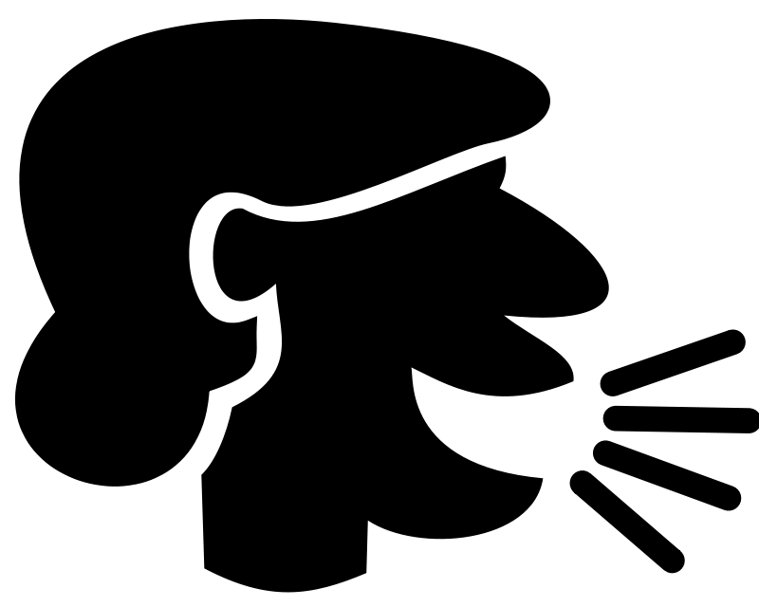

**3.** **THEN SPEAK**

**SESSION 24: NEGOTIATING WITH FAMILY MEMBERS**

*JOURNAL ENTRY*

Today, we practiced how to negotiate with family members.

This week, I will negotiate with…

My ground rules are…

|  |
| --- |
|  |

I want to negotiate…

**Ideas for solutions…**

**SESSION 25: NEGOTIATING SKILLS FOR BOYS AND GIRLS (JOINT SESSION)**

*JOURNAL ENTRY*

Today, we practiced our negotiating skills with other boys.

I learned…

In Session 24, I made a plan to negotiate with 1 family member.

Draw a picture of what happened.

|  |
| --- |
|  |

**SESSION 26: MY GOALS REVISITED – PART 2**

*JOURNAL ENTRY*

Have I reached all of my goals? Put an **X** next to your answer.

|  |  |
| --- | --- |
| * YES | * NO |

If **NO**, this is my plan to reach my goals:

This week I can…

Next week I can…

Next month I can…

If **YES**, then draw a celebration! Congratulations!

|  |
| --- |
|  |

**SESSION 27: POSITIVE CONFLICT MANAGEMENT**

*FACT SHEET*

Today, we learned about how to express EMPATHY, which means putting yourself in another person’s shoes, and how to MANAGE CONFLICT (when we disagree).

Steps to express EMPATHY and understanding:

|  |  |
| --- | --- |
| Step 1.  https://lh4.googleusercontent.com/BMDG_VCu1mxKZIafYfVf3QUvKkVtESlBQm3gbIdTSuAspu8W9kd3n2wvQz-7IDBdbJANgg9vl4CjvEVN95EddbEuMBIqmSvNN7LHzJoQGiZv_mOLu5Vkck5l-_rAiKIGHS3Co7FF | Stay calm. Remember your ground rules. |
| Step 2. | Acknowledge the other person’s emotions. |
| Step 3. | Say what you think you heard the other person say. |

This will help me to communicate calmly even when I disagree!

**SESSION 28: SEXUALLY TRANSMITTED INFECTIONS**

*FACTSHEET*

Today, we learned about SEXUALLY TRANSMITTED INFECTIONS (STIs), including HIV.

***What are STIs?***

STIs are infections usually spread from person to person through sexual activity. Some STIs can also be spread through sharing needles.

Two common STIs are Gonorrhea and Chlamydia. These are bacterial infections.

Three other common STIs are the Human Papilloma Virus (HPV) genital herpes, and the Human Immunodeficiency Virus (HIV). These are viral infections.

***How do I know if I have an STI?***

You may feel:

* A vaginal discharge –more than normal - and that has an odor
* Sores on the vagina
* Bumps on the vulva

Some STIs have no symptoms at all!

Check with a health care provider if you have unprotected sex.

**SESSION 28: SEXUALLY TRANSMITTED INFECTIONS** (CONTINUED)

*FACT SHEET*

***What is HIV?***

HIV stands for Human Immunodeficiency Virus. It **cannot** be cured with medicine.

It is spread through:

* Having sex with someone who is infected with HIV
* Exposed to blood with HIV (e.g. blood transfusions, sharing needles)
* During pregnancy and childbirth if the mother has HIV

***How can I protect myself from STIs?***

* Do not have sex
  + Do not share sharp instruments
  + Get vaccinated for HPV
  + Using condoms correctly and every time when you decide to have sex.
  + When you decide to have sex, get tested regularly.

I also learned…

**SESSION 29: MOVE, GROW, SHINE – NUTRITION FOR TEEN GIRLS**

*FACTSHEET + JOURNAL ENTRY*

Today, we learned about MOVE, GROW, and SHINE foods to keep our bodies healthy.

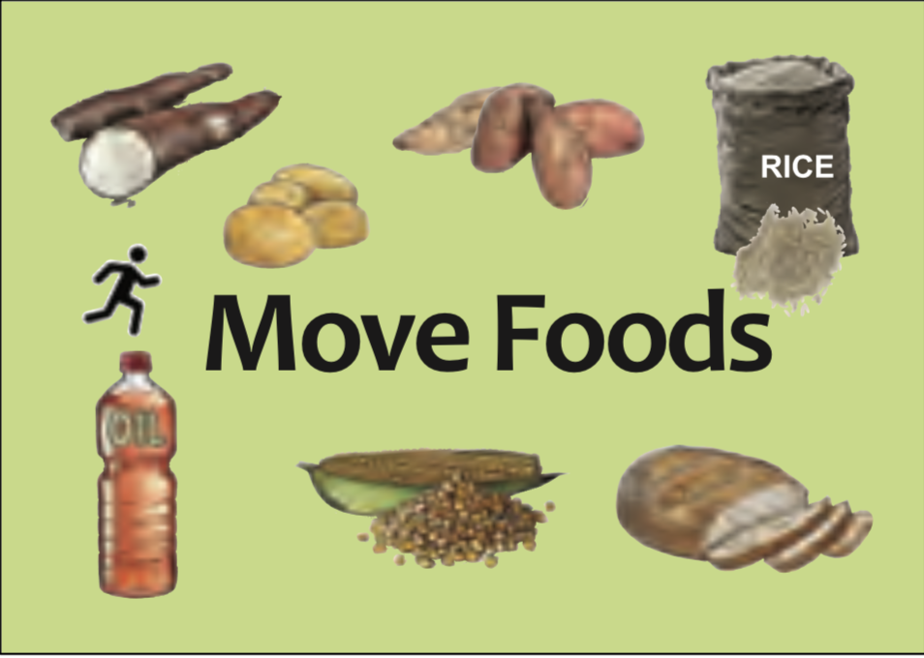

**Move Foods**

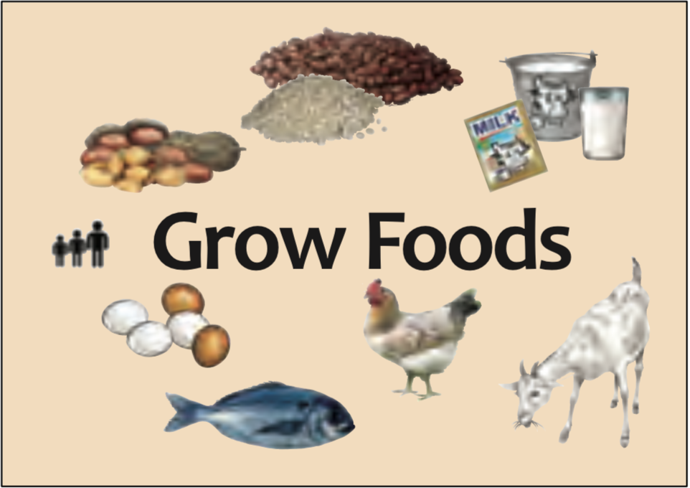

**Grow Foods**

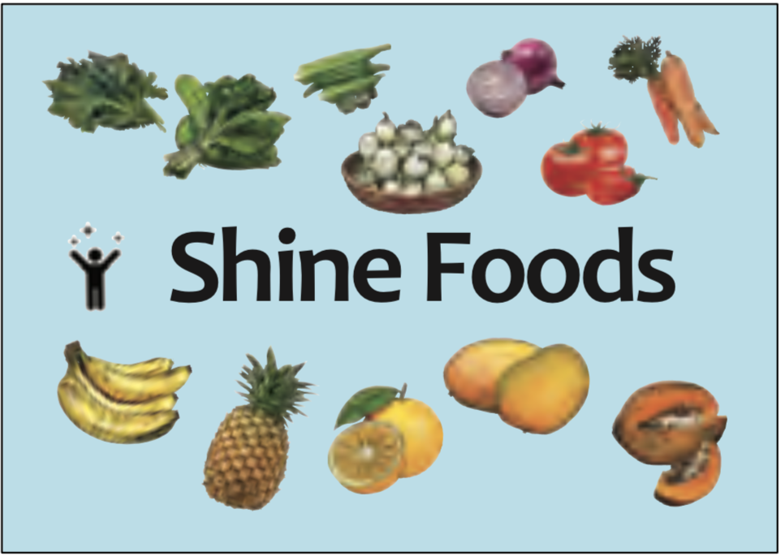

**Shine Foods**

I also learned…

**SESSION 29: MOVE, GROW, SHINE – NUTRITION FOR TEEN GIRLS**

*FACTSHEET + JOURNAL ENTRY*

Draw what Move, Grow, and Shine foods you want on your plate!

**SESSION 30: HOW MUCH SHOULD I EAT?**

*JOURNAL ENTRY*

Today, we learned about how to talk to our family members about Move, Grow, and Shine foods.

I am going to share what I learned about Move, Grow, and Shine foods with… .

If I need help to eat healthy, I will ask…

.

This is me when I feel STRONG!

|  |
| --- |
|  |

**SESSION 31: STAYING SAFE FROM UNWANTED TOUCHES**

*JOURNAL ENTRY*

Today, we learned about how to stay safe from TOUCHES I DO NOT LIKE.

This is my song!

*From the top of my head,*

*to the bottom of my feet,*

*my body belongs to me.*

*I can say NO.*

*I can TELL.*

*I can GET AWAY when I don’t feel safe! [[4]](#footnote-5)*

If I do not like when someone touches me, I will do this…

I will tell…

**SESSION 32: MODEL WOMEN IN THE COMMUNITY – PART 3**

*JOURNAL ENTRY*

Today, we met another Model Woman from the community.

Her name was…

I liked her story because…

This is me as a Model Woman.

|  |
| --- |
|  |

**SESSION 33: CHANGING GENDER ROLES**

*JOURNAL ENTRY*

Today, we learned about how GENDER ROLES change over time.

In the box, draw activities both boys *AND* girls can do.

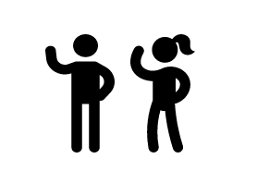



**SESSION 34: SCHOOL SONG AND DANCE**

*JOURNAL ENTRY*

Today, we did songs, dances, and dramas about staying in school.

My team did a… *(circle one)* SONG/DANCE DRAMA

It was so…. *(circle how you feel!)*

|  |  |  |  |
| --- | --- | --- | --- |
| FUN | EXCITING | FAST | COOL |
| FUNNY | HAPPY | BORING | GOOD |
| JOYFUL | SAD | AMAZING | BAD |

This is a picture of me and my team today!

|  |
| --- |
|  |

**SESSION 35: ANEMIA PREVENTION**

*JOURNAL ENTRY*

Today, we learned about ANEMIA. ANEMIA is when you do not have enough iron in your blood.

To prevent anemia, I need to eat lots of Grow and Shine foods.

**Shine Foods**

**Grow Foods**

I also learned…

I will share what I learned with…

**SESSION 36: WHO AM I?**

*FACTSHEET*

Today, we learned about GENDER IDENTITY, and GENDER EXPRESSION, SEXUAL ORIENTATION.

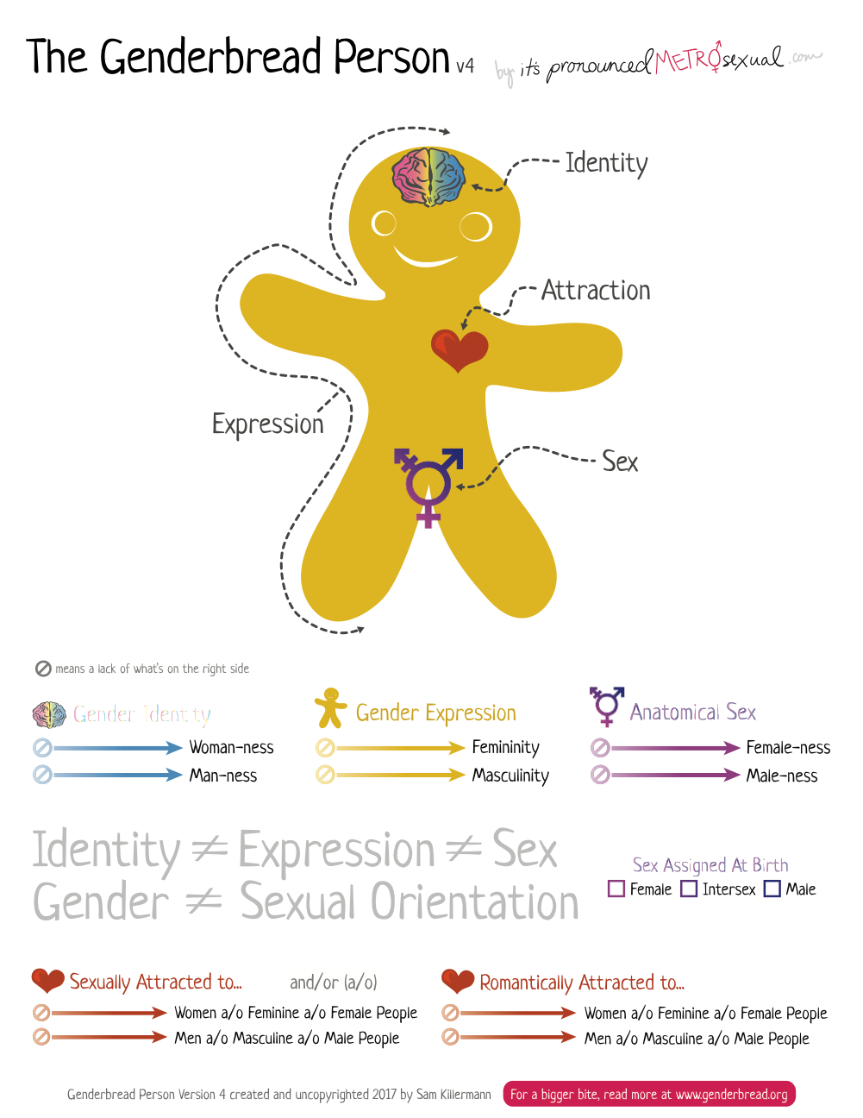

**SESSION 37: I LOVE EXERCISE!**

*JOURNAL ENTRY*

Today, we learned about EXERCISE.

It is good to exercise because…

* I am growing strong muscles.
* I need to have fun and release energy!
* Having fun brings blood to my brain and helps me learn.

This is how I will exercise and stay strong!

|  |
| --- |
|  |

**SESSION 38: SAVINGS AND LOAN GROUPS**

*JOURNAL ENTRY*

Today, we learned about SAVINGS and LOAN GROUPS. These groups can help me to better save and invest my money.



**$$**

I also learned…

I will tell about what I learned today.

**SESSION 39: COMMUNITY MAPPING AND SAFETY**

*JOURNAL ENTRY*

Today, we learned about how to keep the community safe for everyone.

If I need help to be safe, I can go to… *(circle)*

|  |  |  |
| --- | --- | --- |
| My mother | My father | My auntie |
| My uncle | My friend | My teacher |
| A representative of women’s rights | Community leader | The police |
| My brother | My sister |  |

This is a picture of my community when it is safe for both boys and girls!

|  |
| --- |
|  |

**SESSION 40: WRAP UP**

*JOURNAL ENTRY*

***CONGRATULATIONS!***

You have learned so much!



Draw in the bubbles below what you have learned about each topic.

**Finance**

**Gender**

**Safety from Violence**

**Education**

**Communication**

**Health**

1. Image from the Very Young Adolescence 2.0 Curriculum by Promundo-US. [↑](#footnote-ref-2)
2. Infographic from World Health Organization on FGM: <https://www.who.int/reproductivehealth/publications/fgm/fgm-infographic-3.pdf?ua=1>. [↑](#footnote-ref-3)
3. Infographic from the International Federation of the Red Cross and Red Crescent Societies. <https://www.ifrc.org/Global/Photos/Asia%20Pacific/GBV%20page/GBV%20infographic_FINAL3.pdf> [↑](#footnote-ref-4)
4. From Interface Family and Children Services’ Toolkit: <https://www.icfs.org/wp-content/uploads/My-Body-Belongs-To-Me-Toolkit-English.pdf> [↑](#footnote-ref-5)